Robeson County Vision Zero

Version 2.0 – March 1, 2021

Thank you for getting the word out about the importance of improving driver behavior in Robeson County. With your help, we can save reduce traffic deaths. Below are some suggested social media messages and graphics/visuals you can use on your accounts to reach your followers/audiences.

  - Facebook image

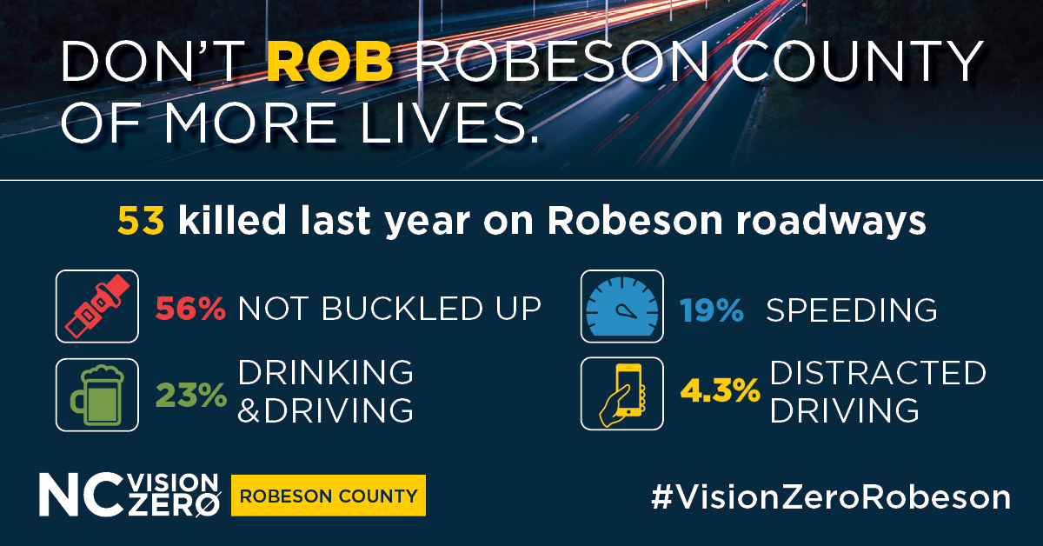

Version 1:
Follow these basic rules of the road; the life you save may be your own.
The number of fatal crashes rose last year in Robeson County. Find out why: https://bit.ly/2MSklKb

Version 2:
Save a life in Robeson County. Don’t make these same mistakes.
Find out why more people died in crashes in Robeson last year: https://bit.ly/2MSklKb
Be part of the solution ➡️ ncvisionzero.org/robeson

  - Twitter – GIF

Version 1:
Last year, 53 people died in 🚗 crashes in Robeson Co.
- +50% not wearing seat belts
- 23% had consumed alcohol
Get involved ➡️ ncvisionzero.org/robeson
#VisionZeroRobeson #NCGHSP

Version 2:
DYK 85% of all fatal crashes or serious injuries in Robeson Co. occurred in rural areas? (2017-20)
53 killed in Robeson crashes last year.
+50% weren’t buckled up.
More ➡️ https://bit.ly/2MSklKb
#VisionZeroRobeson #NCGHSP

