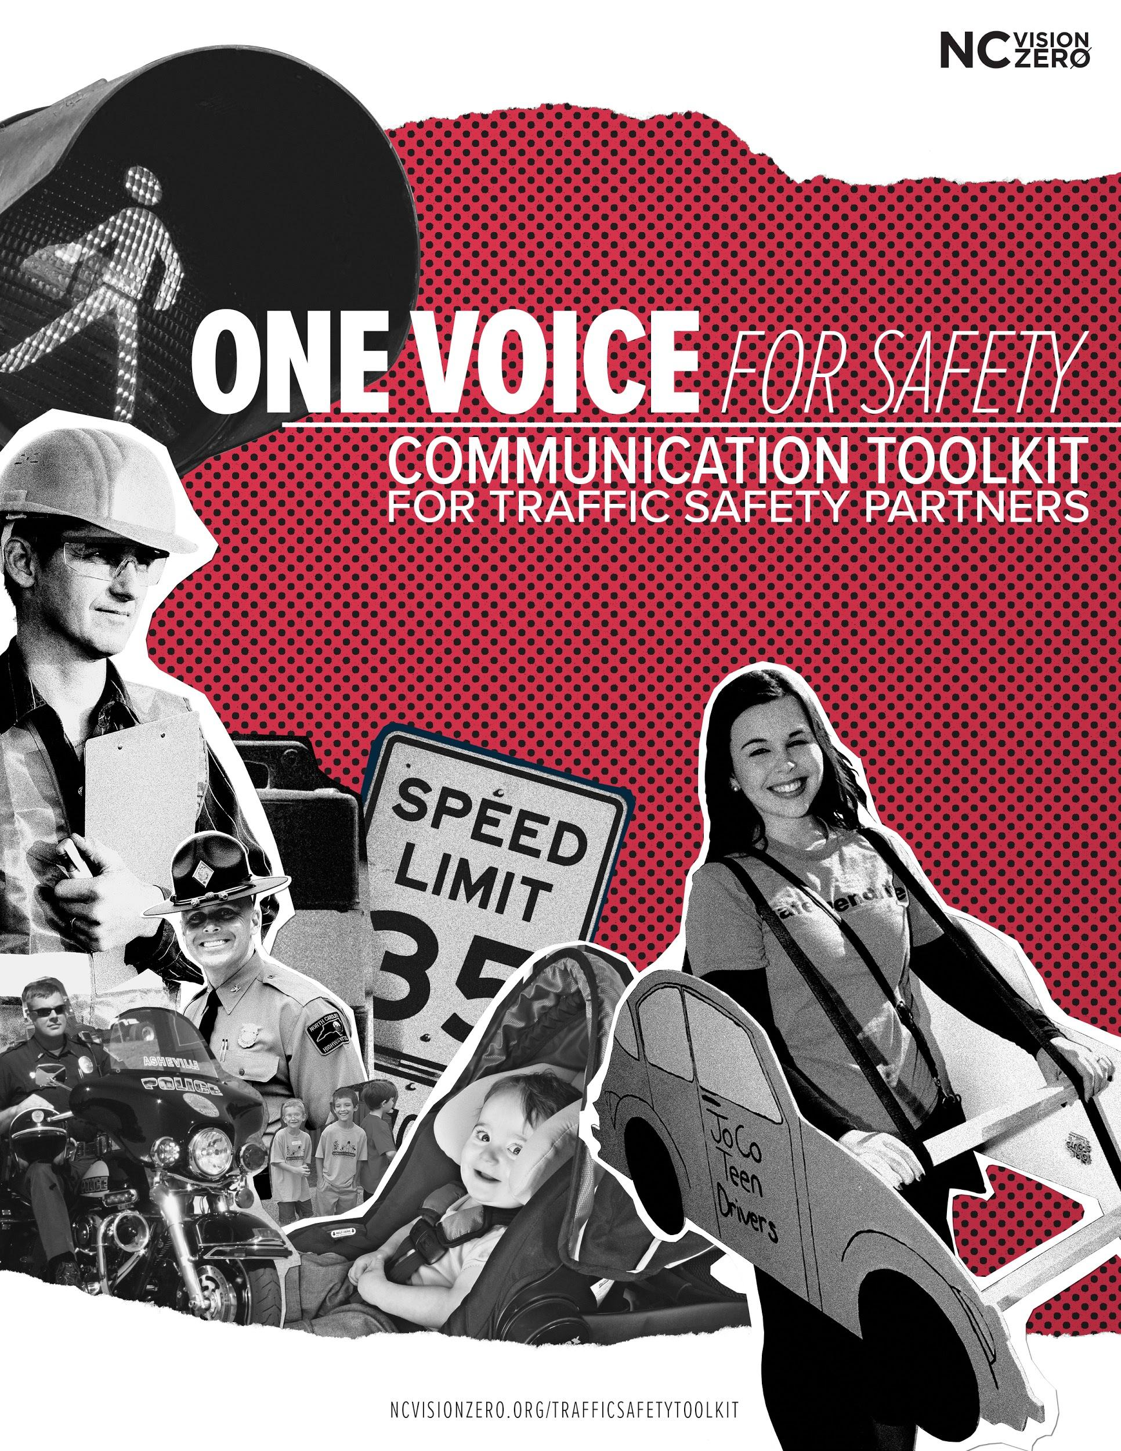

Note: This toolkit is under development. For additions or suggestions, contact: ncvisionzero@ncsu.edu.

Table of Contents

Communication Strategies 4
Tips and Guidelines 4
Social Media Content 5
General traffic safety messaging/Vision Zero messaging 5
Parents 9
Weather 10
Crash Not Accident 11
Enforcement Campaigns 12
Booze It and Lose It 12
Safety Focus Areas 15
Bicycle Safety 15
Child Passenger Safety 20
Distracted Driving 21
Drinking and driving 23
Drowsy Driving 25
Drugged driving 27
Pedestrian Safety 28
Teen Driver 31
Seat belt safety 33
Speeding 38
School Bus 40
Large Truck/CMV Safety 41
Motorcycle Safety 42
Work Zone Safety 43
Holidays 44
New Years 44
Valentine’s Day 44
July 4th 45
Halloween 46
Christmas 47
Law Enforcement 48
Additional Content 49
Videos 49
Images 49

Communication Strategies

Tips and Guidelines

DO
- Emphasize positive community norms. For example, “Most North Carolinians do not use a phone behind the wheel.”
- Highlight safe behaviors and the power of each individual to avoid injury. For example, “Buckle up to save your life!” rather than “Buckle up or be injured/killed.”
- Include a visual element with every post, including a picture, gif, or video.
- Tag relevant partners on posts to reach a wider network of traffic safety partners and increase engagement.
- Tailor messages to a specific audience or peer crowd.
- Respond to private messages, replies, and comments on your page to engage directly with followers and open informal conversation.
- Check analytic tools for social media pages to improve reach and engagement, including Facebook Insights and Twitter Analytics.

DON’T
- Use “car accident.” To emphasize the power of personal choices and each person’s responsibility on the road, avoid using the term “accident.” Instead, describe incidents as a crash or collision. More information here.
- Use fear appeals and graphic or gory images (including bloody scenes, crunched up cars, etc.). Research shows that scare tactics, gore, and fear appeals do not influence behavior. Instead, use positive social health behavior messaging. For example, rather than using a message such as “Wear a seat belt or die!” encourage the healthy behavior, such as “Wear a seat belt to save your life!”

Helpful tools
- Save time by using a social media scheduling app - such as Hootsuite or Social Pilot. This will allow you to write content on your own schedule and plan out when it will post in the future.
- Tweriod is a free service which tells you the best times to post when your followers are on Twitter - allowing you to schedule posts and maximize reach.

Social Media Content
*Note: Tags listed in the following posts are relevant for Facebook accounts only. Search other platforms (Twitter, Instagram, etc.) to see if an organization has a different tag for other pages.

General traffic safety messaging/Vision Zero messaging

Post | Preview of Visual
It’s time to challenge the status quo and adopt a zero tolerance approach to traffic violence. Too many lives are lost each year to selfish decisions on the road. Zero is the only acceptable goal. @ncvisionzero https://goo.gl/t5cG9e | 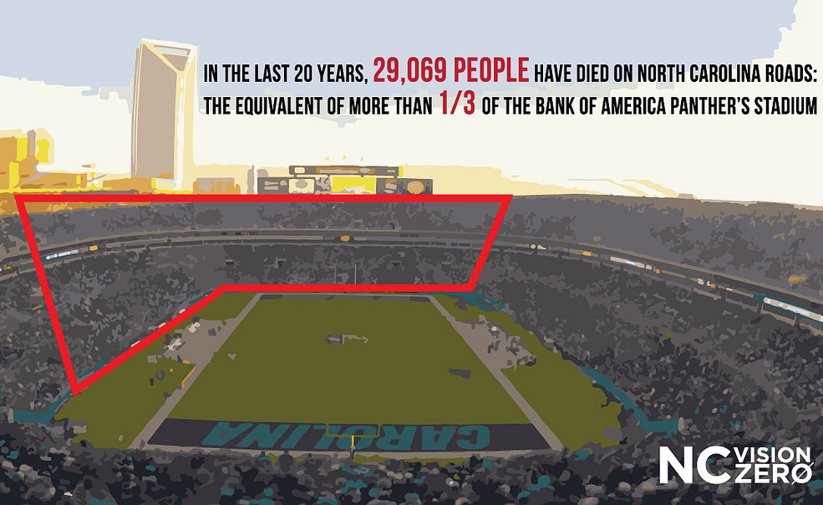
No one likes a surprise on the road. #communicate #turnsignals @ncvisionzero https://goo.gl/YcbXQi | 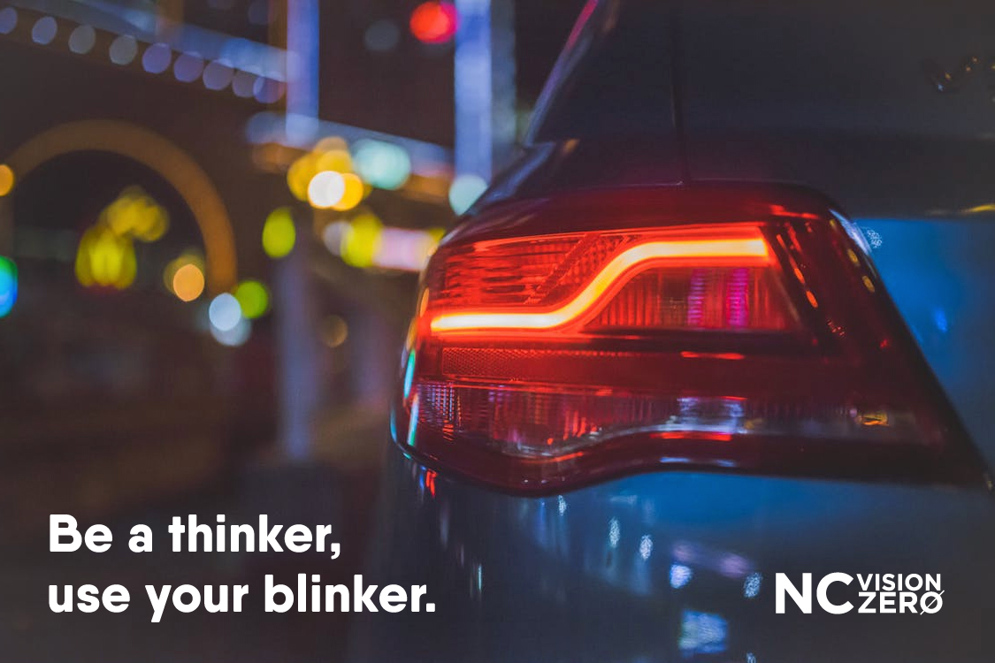
Reaching the ultimate level of driving consciousness. #wholesome @ncvisionzero https://bit.ly/2qlitu1 | 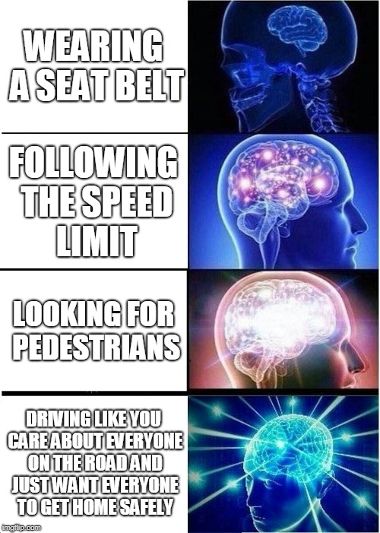
This public health crisis is in our reach. Crashes are preventable. #yourchoicesmatter @NCVisionZero https://goo.gl/SWGAaS | 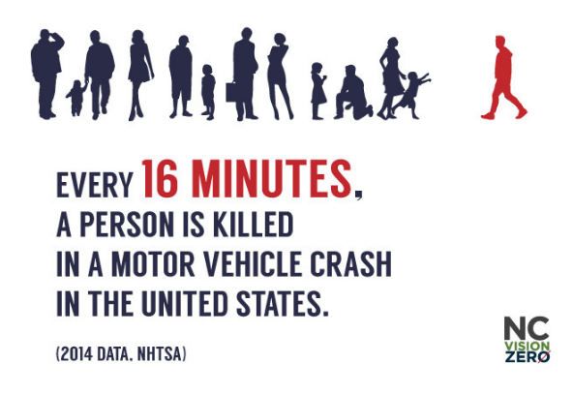
Anytime you are in a vehicle, you have the power to prevent a crash. #EmpoweredPassenger #speakup @ncvisionzero https://goo.gl/Gpgkuo | 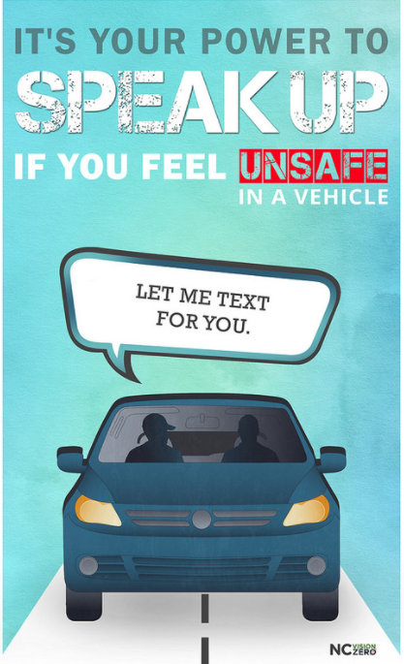
Anytime you are in a vehicle, you have the power to prevent a crash. #Speakup for safety. This makes you an #EmpoweredPassenger. @ncvisionzero | 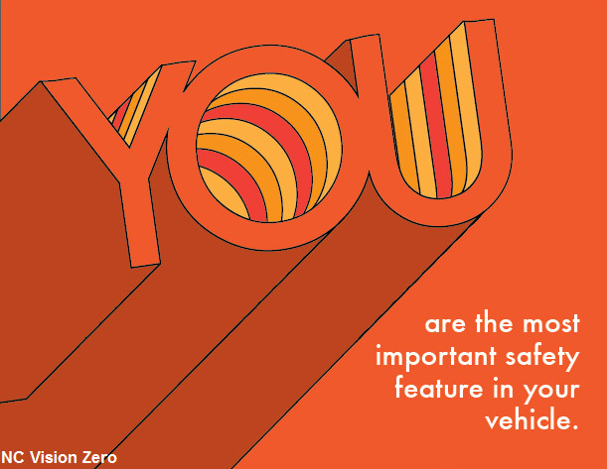
The closer you are to the car in front of you, the more impossible it is to stop without hitting them. #commonsense #leavespace #stoppingdistance #whatstherush @ncvisionzero https://goo.gl/images/bZrJ81 | 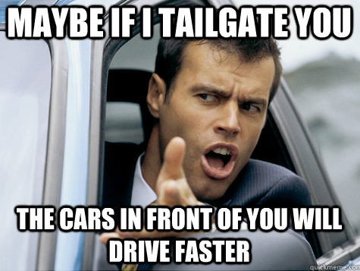
Personal trauma, the anguish of loss, an experience for which you were lamentably unprepared-- What does it mean - what can it mean - if you keep it hidden inside? #ShareYourStory at ncvisionzero.org/share. @ncvisionzero https://bit.ly/2HnEQr3 | 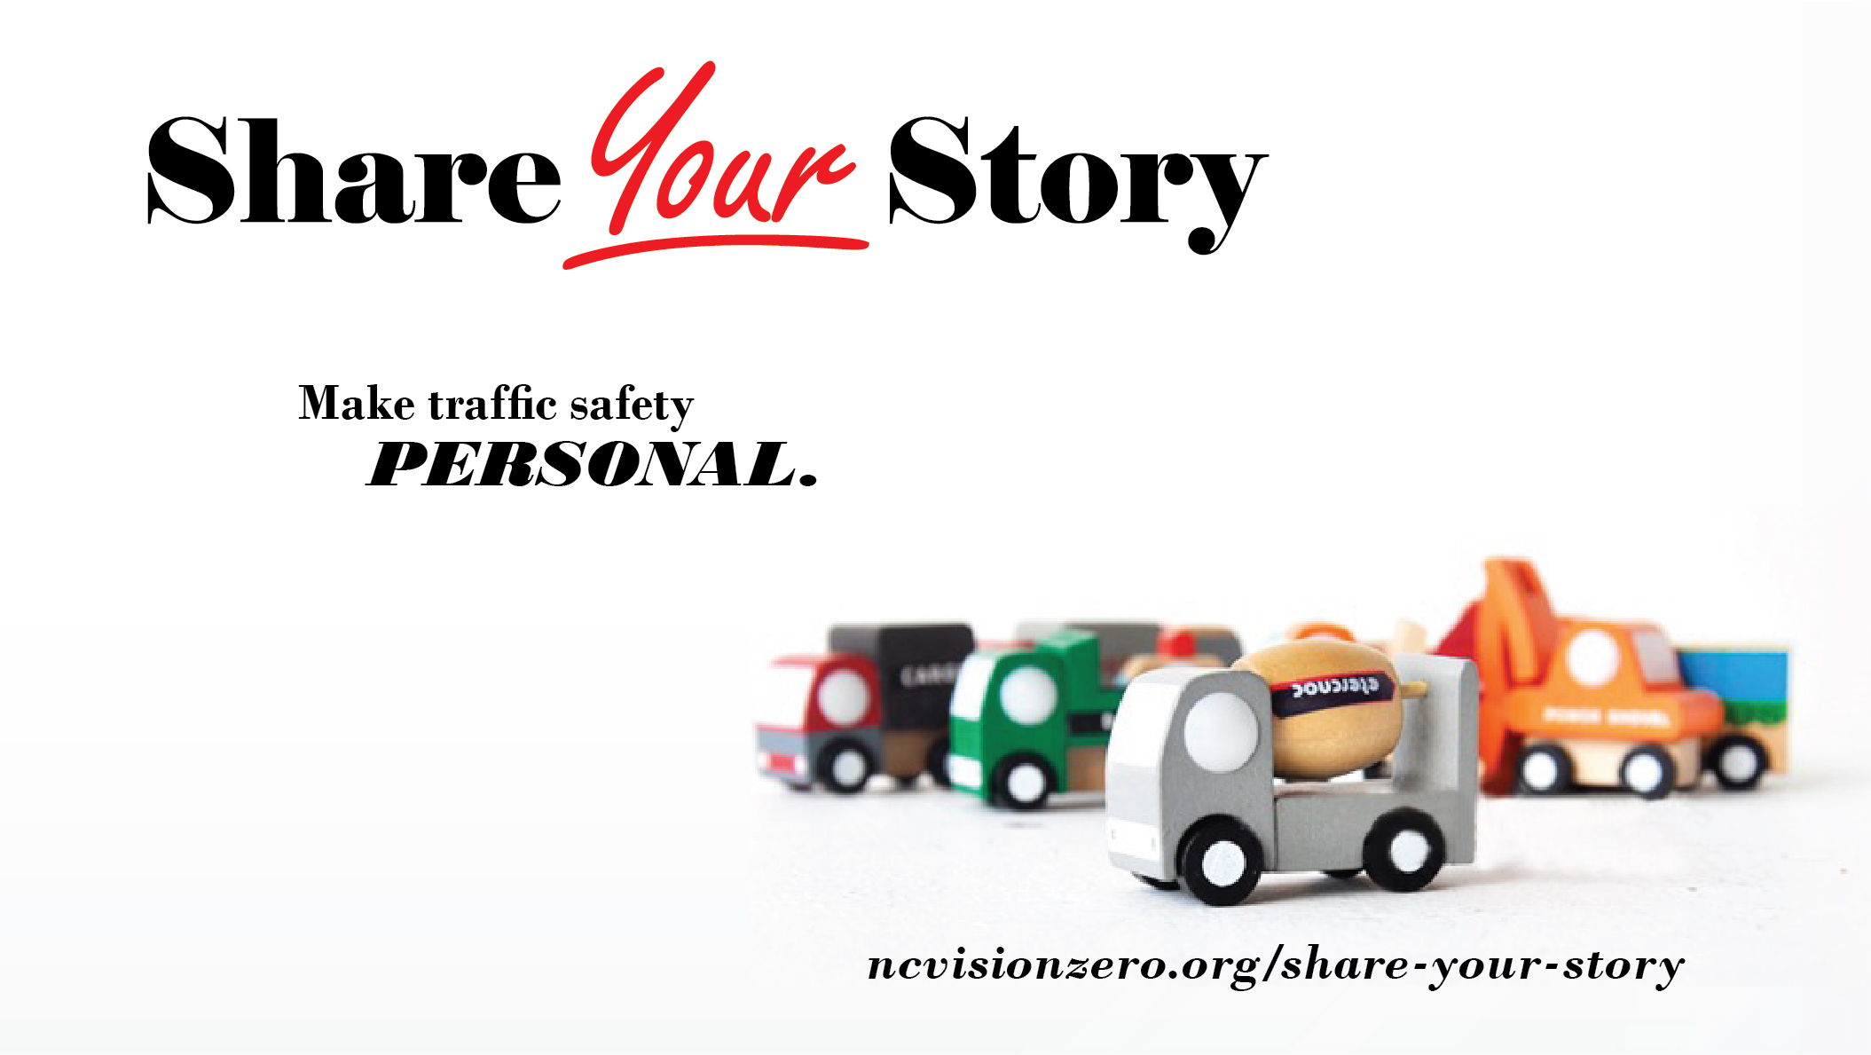
Do you know someone with a story to tell about traffic safety? Encourage him to tell it at ncvisionzero.org/share! @ncvisionzero https://bit.ly/2HnEQr3
Your story is only about you - until you tell it. Then, it's history. That's a big deal. #ShareYourStory about traffic safety at ncvisionzero.org/share. @ncvisionzero https://bit.ly/2HnEQr3

Parents

Post | Preview of Visual
Children observe and absorb your behavior like a sponge. What kind of driver are you raising? #kidsarecopycats @ncvisionzero https://goo.gl/mnVDG7 | 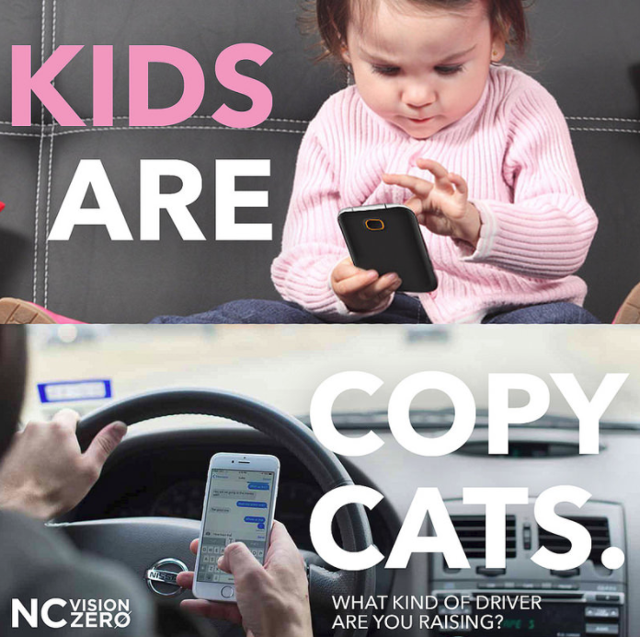
Parents, #resist driving distracted for your kids. #distracteddriving @ncvisionzero @zerofatalities | (video)  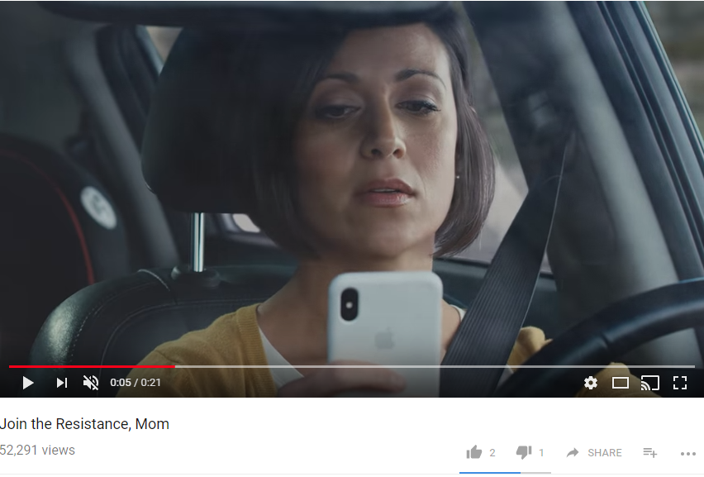

Weather

Post | Preview of Visual
Make sure others can see you in bad weather. @ncvisionzero https://goo.gl/jM98wq | 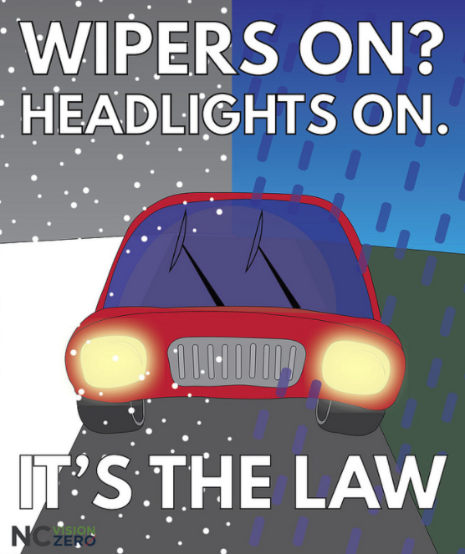
Wipers and headlights belong together. @ncvisionzero http://gph.is/2po4WSb | (gif)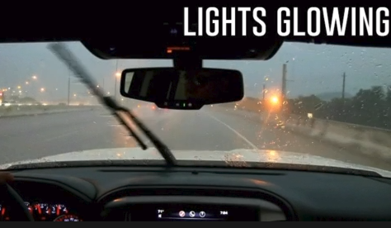

Crash Not Accident

Post | Preview of Visual
A collision resulting from someone drinking and driving or looking down at a phone is no “accident” - it’s a crash. #crashnotaccident @NCVisionZero https://goo.gl/images/2rdkaq
The language that we use to describe motor vehicle crashes has great influence on how we perceive our personal power and responsibility to prevent traffic violence. Let’s be clear: Crashes are preventable. #crashnotaccident @NCVisionZero https://goo.gl/images/2rdkaq

Enforcement Campaigns

Booze It and Lose It

Post | Preview of Visual
You work hard. Take a well-deserved break this #LaborDay. But, if you drink don’t drive.  @NCVisionZero https://goo.gl/images/hBUx1y | 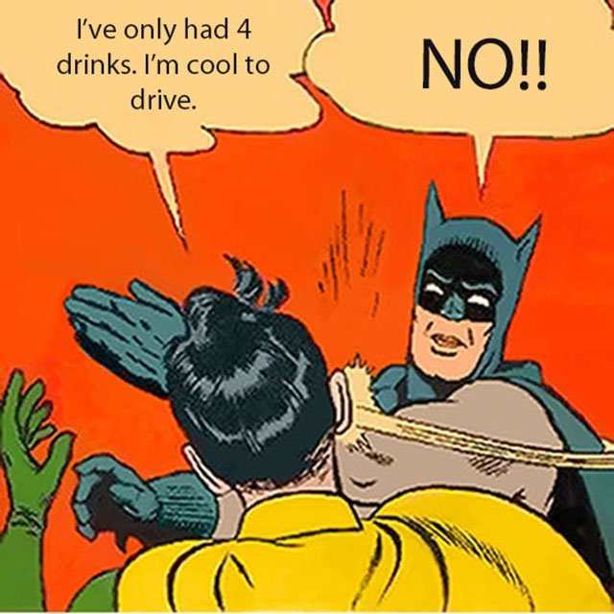
A DWI is expensive. You have plenty of options. You can find a sober ride home. #notworththerisk #BoozeIt&LoseIt @NCVisionZero https://goo.gl/wYPu1M | (gif)  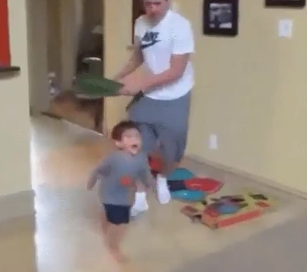
This #LaborDay, start the party, not your car. #BoozeItAndLoseIt @NCVisionZero https://goo.gl/UwpkqH | (video)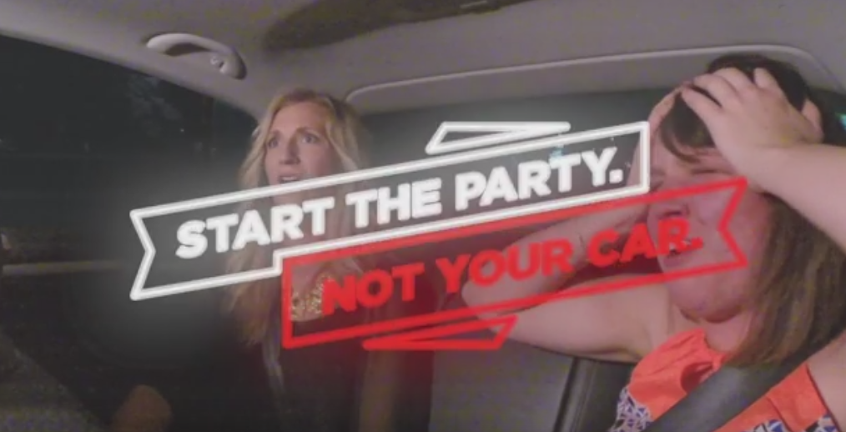
Enjoy #LaborDay with friends--but, do elect a designated driver. #BoozeItAndLoseIt @ITRE_NCSU @NCVisionZero  https://bit.ly/2JyG2Zo | (video)  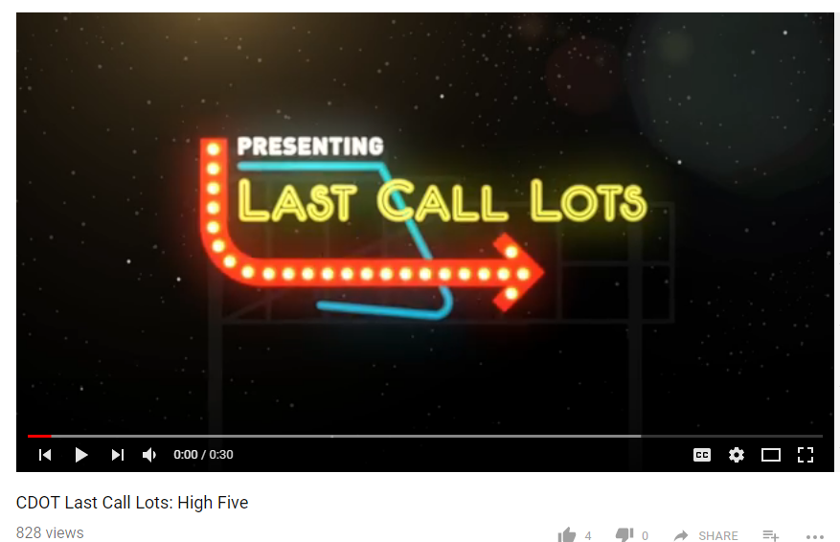
A DWI is expensive. You have plenty of options--you _can_ find a sober ride home. #BoozeItAndLoseIt @NCVisionZero | (video)  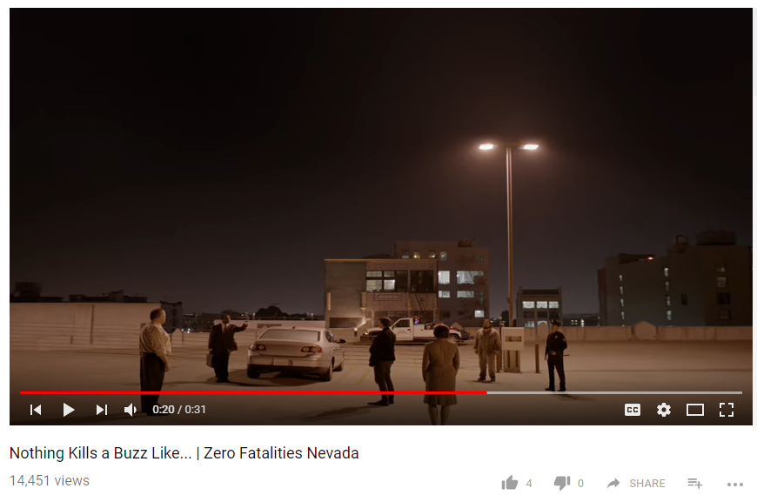
Take a load off this #LaborDay. --But, if your celebrations include alcohol, don’t drive. #BoozeItAndLoseIt @NCVisionZero https://bit.ly/2qeNYH5 | (video)  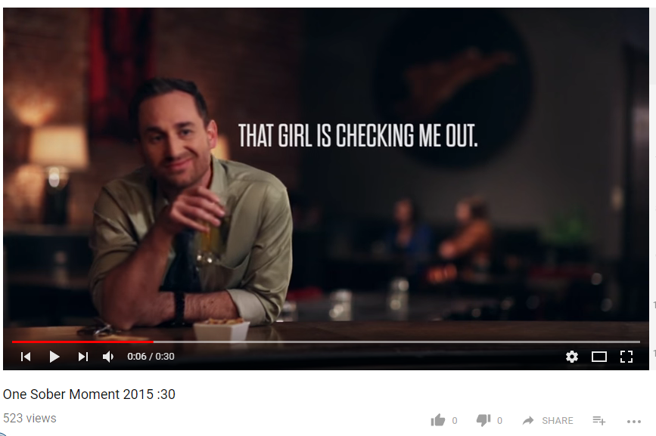
Deaths attributed to drunk driving were fewer in 2016 than in any of the preceding 5 years. North Carolina police are fighting the good fight--but drunk driving still accounts for 27% of all roadway fatalities.  Police will be working extra-hard this week and next to preserve you against the scourge of drunk driving.  #BoozeItandLoseIt @NCVisionZero https://goo.gl/images/H3i3iw | 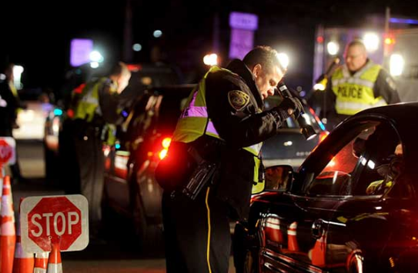
Alcohol is insidious. It impairs your ability to drive--but, it also impairs your ability to _reason_. You know you should not drink and drive. Will you know you should not drive _after several drinks_? Plan sober. Then, stick to the plan.  #BoozeItandLoseIt @NCVisionZero https://bit.ly/2GOJD7F | (video)  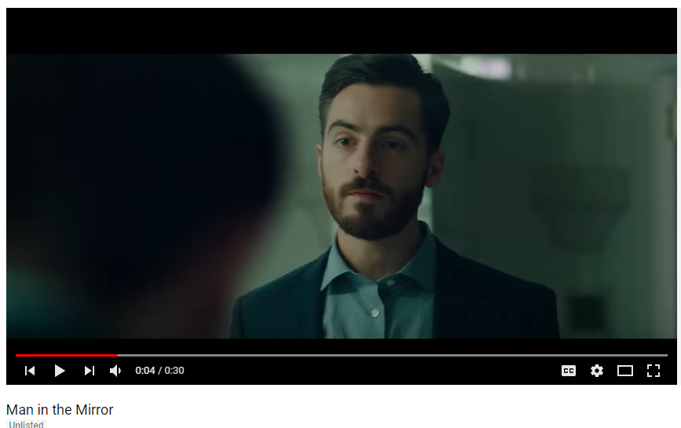

Safety Focus Areas

Bicycle Safety

Post | Preview of Visual
Change lanes to bass cyclists. #sharetheroad #watchformenc @bikewalknc @ncvisionzero https://goo.gl/images/Eyjpnk | 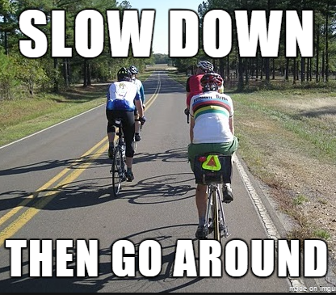
Human powered vehicles have a right to the road. Always look for cyclists before turning. #sharetheroad #watchformenc @ncvisionzero https://bit.ly/2IfPqPP | (video)  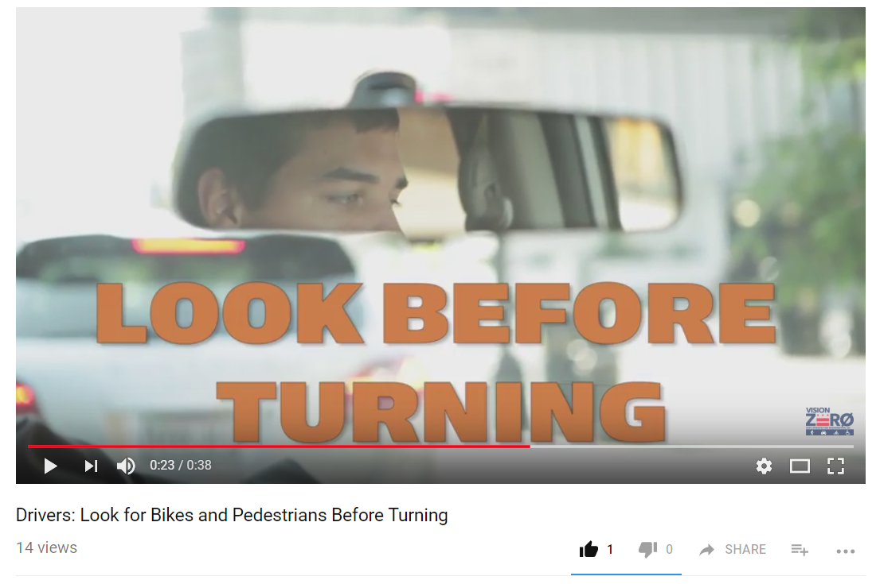
A car and a bicycle can’t fit in the same lane. Change lanes to pass cyclists. #sharetheroad #watchformenc @bikewalknc @ncvisionzero https://goo.gl/images/ji6kK5 | 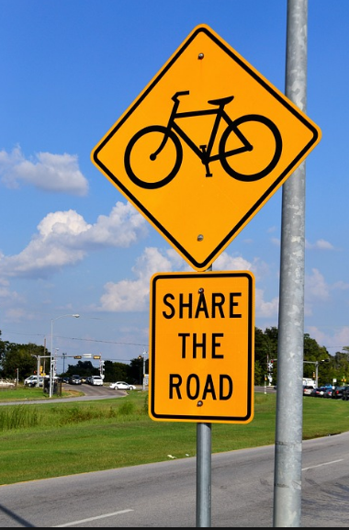
Bicycles are vehicles. #samerights #samerules #sharetheroad #watchforme @bikewalknc @ncvisionzero https://gph.is/2glGwWs | (gif)  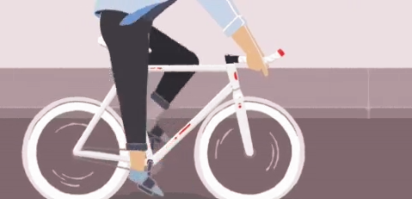
On the road, we all have to watch for each other and travel with mutual understanding. #WatchForMeNC @ncvisionzero @bikewalknc https://bit.ly/2GdAHs6 | (video)  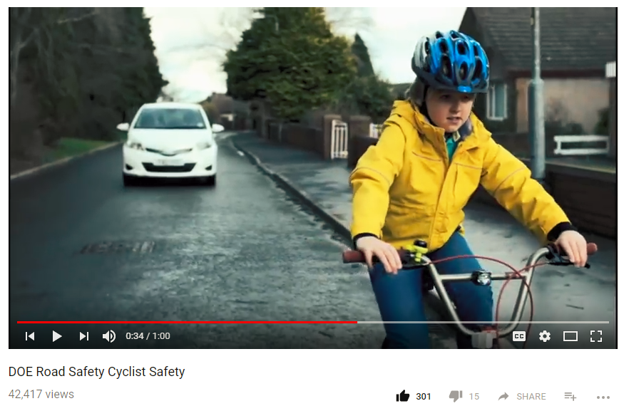
Can you pass this awareness test? #WatchForMeNC @bikewalknc @ncvisionzero https://bit.ly/2GbQTue | (video)  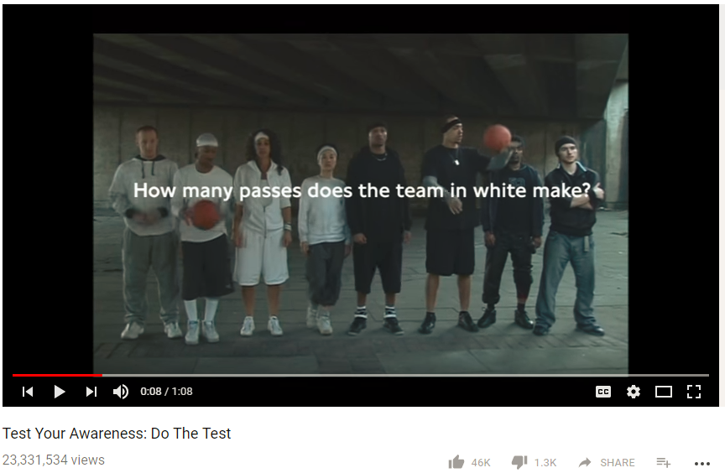
Anywhere else in life, it’s awkward. On the road, it’s dangerous. #leavespace #sharetheroad #WatchForMeNC @ncvisionzero @bikewalknc https://bit.ly/2GBlPU9 | (video)  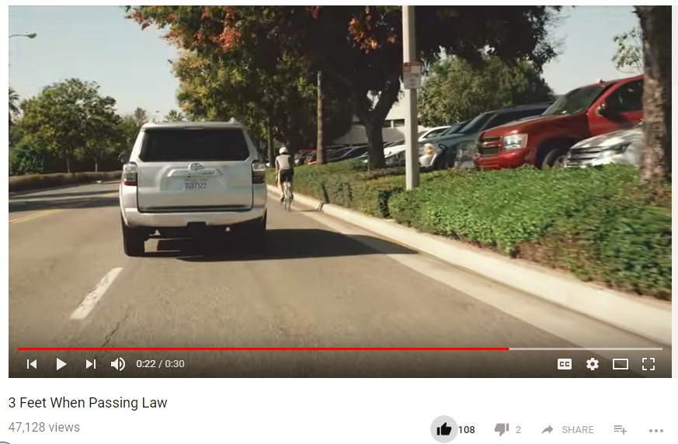
We all share the road. #Respect cyclists. #WatchForMe @ncvisionzero @bikewalknc https://bit.ly/2GbTpka | (video)  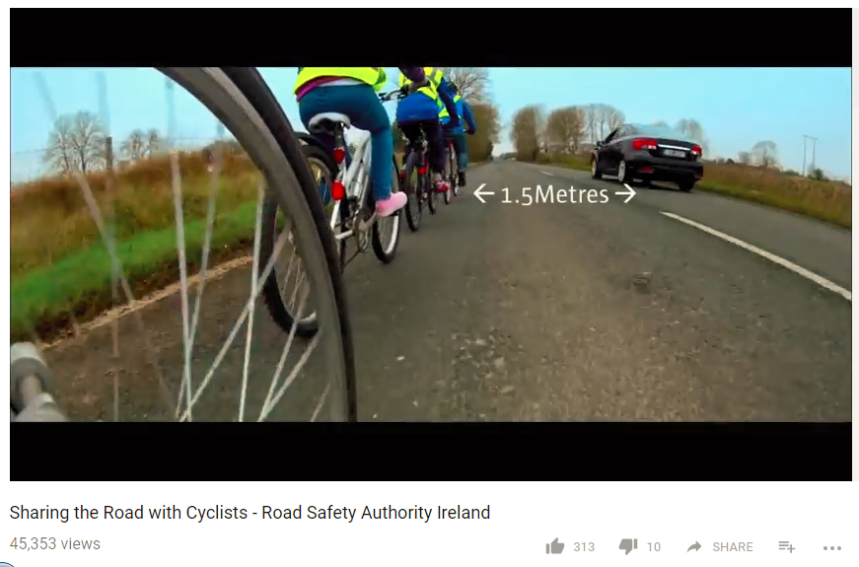
@Blackstonebikes - a community bike shop and youth education program gives #bicyclesafety tips with style. #trafficsafetymusic @ncvisionzero @bikewalknc https://bit.ly/2IWNRHW | (video)  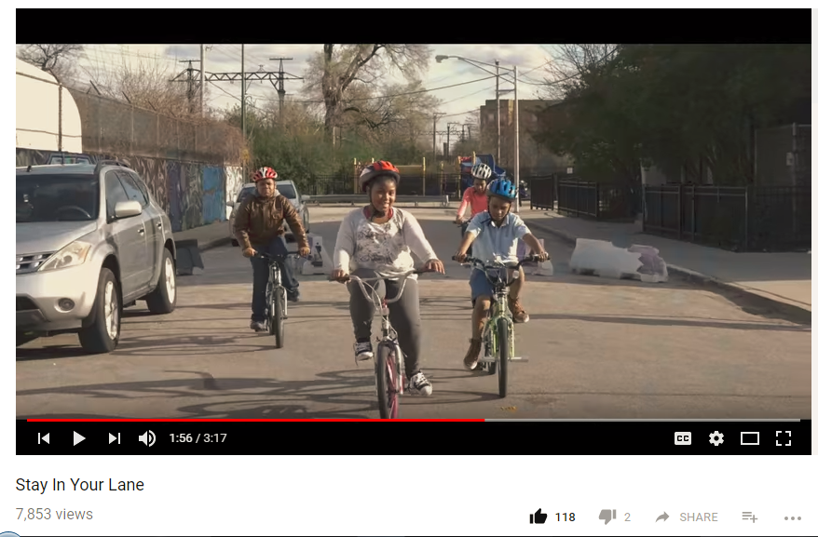
60 kph = 37 mph #leavespace #sharetheroad #watchformenc @bikewalknc @ncvisionzero https://bit.ly/2pS1OOB | (video)  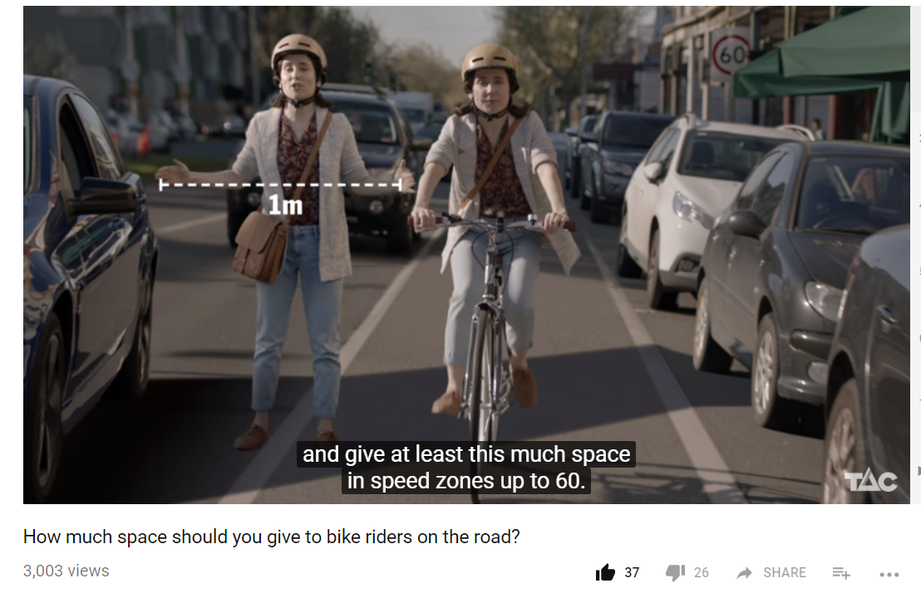
We must all be vigilant as we #sharetheroad. Before jumping out of your car, looking for oncoming cyclists. #dutchreach #watchformenc @ncvisionzero https://bit.ly/2GKKBAW | (video)  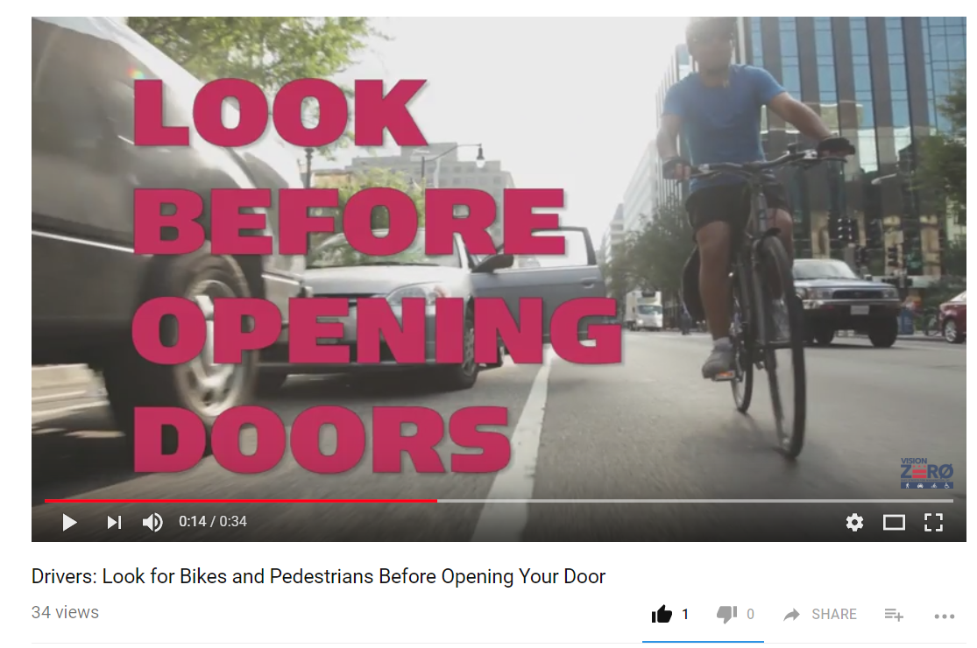
Bicycles are vehicles. That means we all have the #samerights and must follow the #samerules. @ncvisionzero https://bit.ly/2GkuuLc | (video)  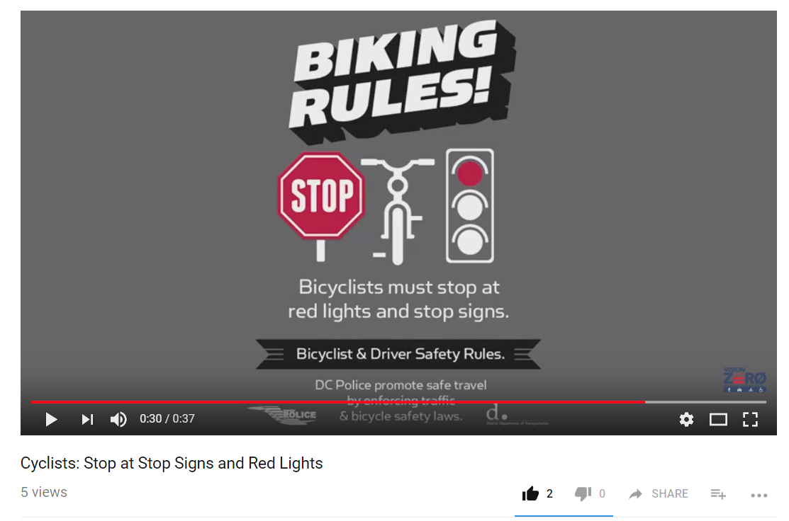

Child Passenger Safety

Post | Preview of Visual
Your children rely on you. Have you checked lately? Is your child in the #rightseat? Find out here: http://www.buckleupnc.org/choosing-using/ @hsrcinfo @ncvisionzero @ncsafekids  https://goo.gl/24u2A5 | 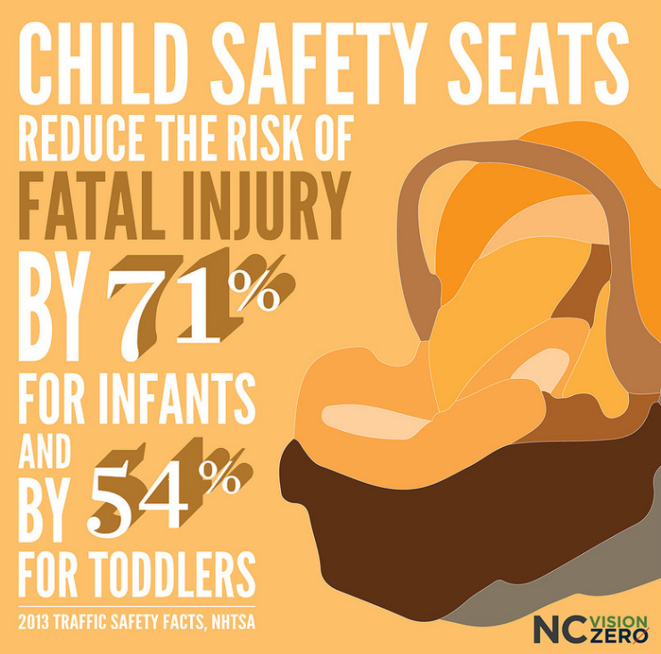
Is your child in the #rightseat? Most parents aren’t sure. http://www.buckleupnc.org/choosing-using/ @ncvisionzero @hsrcinfo https://goo.gl/images/BQQWpE | 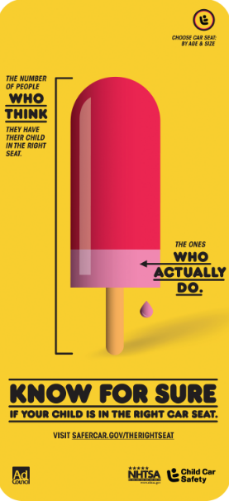
Car seats can be complicated. But they don’t have to be! Check out this information from @hsrcinfo to make sure you’re using #therightseat. @ncvisionzero http://www.buckleupnc.org/choosing-using/  https://goo.gl/images/vF8reX | 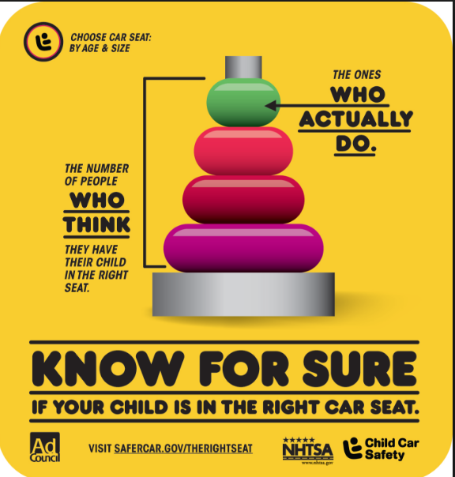

Distracted Driving

Post | Preview of Visual
When your eyes aren’t on the road, you can’t perceive obstacles and risks quickly enough to stop safely. #JustDrive @ncvisionzero https://bit.ly/2Ey8RBe | 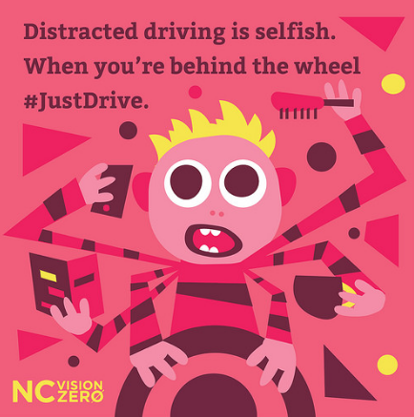
You can do it. Rebel against distraction! #jointheresistance #JustDriveNC @ncvisionzero https://goo.gl/c5zzSn | (video)  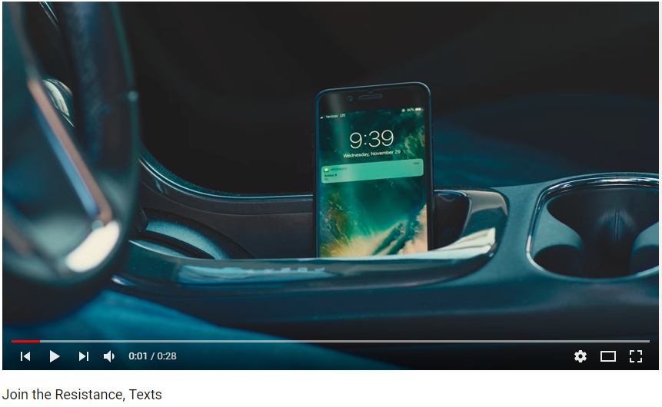
You can live without it. #JustDrive @ncvisionzero https://bit.ly/2JgXvp1 | (video)  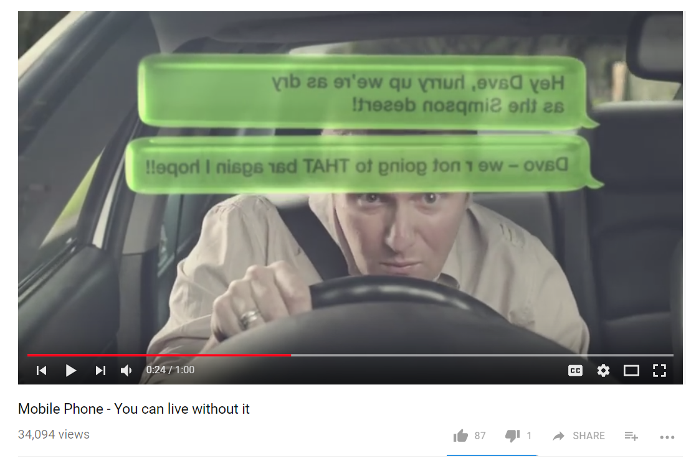
#Distracteddriving is selfish. #JustDrive @ncvisionzero https://bit.ly/2Gy9dKa | (video)  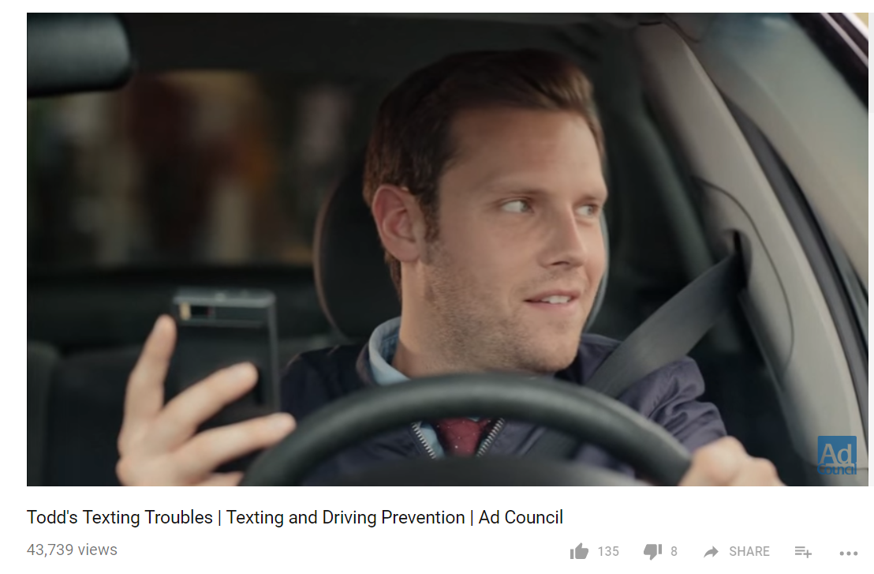
Silence your distractions while driving - or at least put them out of reach. When you drive, #JustDrive. @ncvisionzero https://bit.ly/2Jgdy6c | (video)  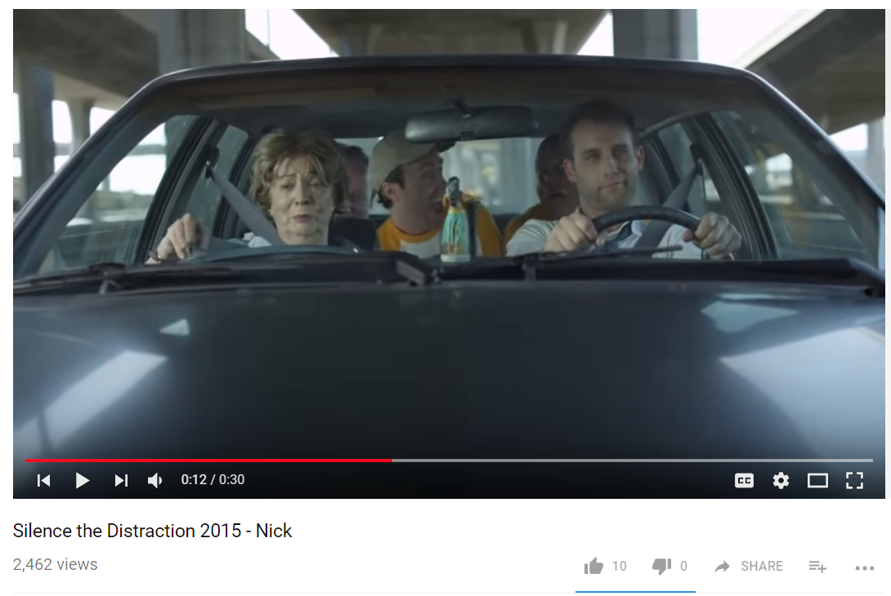
Our phones are like an extension of ourselves. But when you drive, #justdrive. @ncvisionzero https://bit.ly/2Imz3B2 | (video)  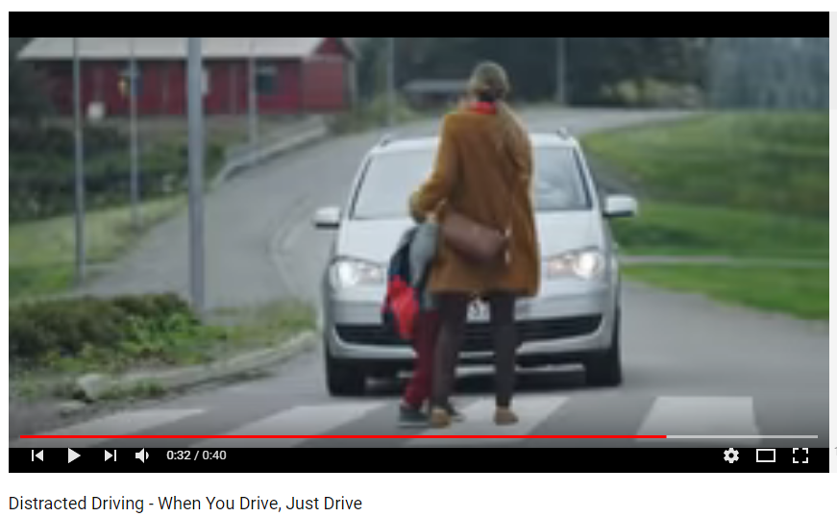

Drinking and driving

Post | Preview of Visual
Only villains drive after drinking. #batman #drivesober #checkyourself @madd.official @ncvisionzero | 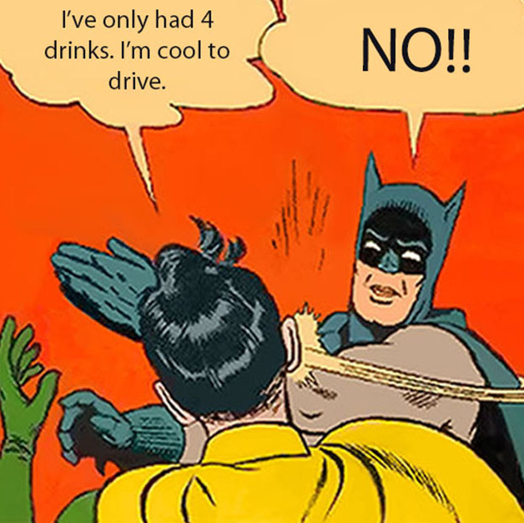
Easy choice. Let #Lyft or #Uber get you home safely. @ncvisionzero https://bit.ly/2v2NDvO | 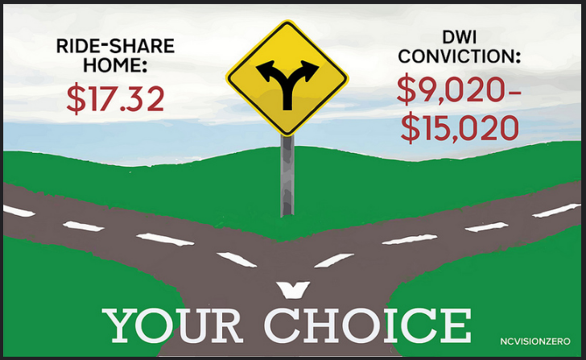
The best part of a house party is a comfy couch to crash in. #itsjusteasier @ncvisionzero https://bit.ly/2IETppw | 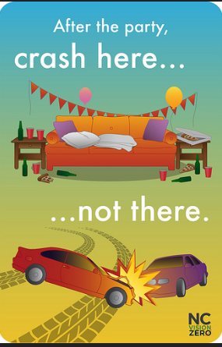

Drowsy Driving

Post | Preview of Visual
You can’t fight sleep. Being tired is as dangerous as being drunk on the road. @ncvisionzero https://goo.gl/VzU7YJ | 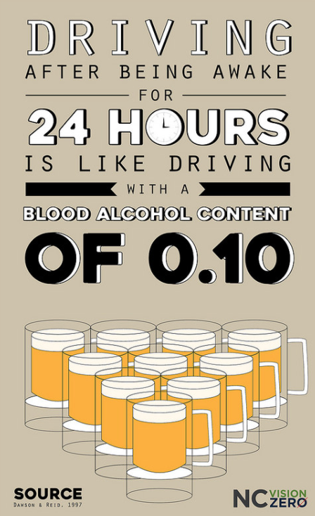
Most drowsy driving crashes involve a single vehicle leaving the roadway at a high speed with no sign of breaking. You can’t fight sleep. Take a break. Take a nap in a safe place. #drowsydriving @ncvisionzero https://goo.gl/CyniHm | 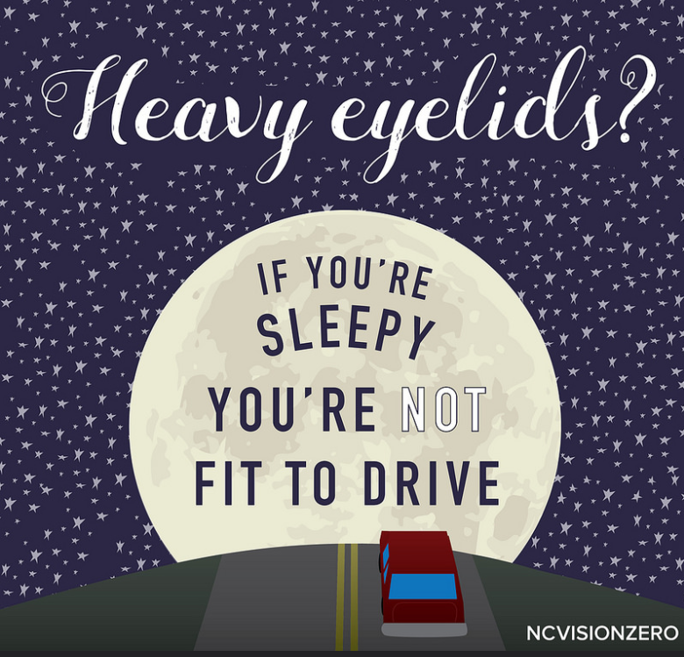

Drugged driving

Post | Preview of Visual
DUI laws aren’t limited to illegal drugs and alcohol. Check your prescription to be sure - is it safe to drive on your medication? #druggeddriving @ncvisionzero https://goo.gl/2hECqs | 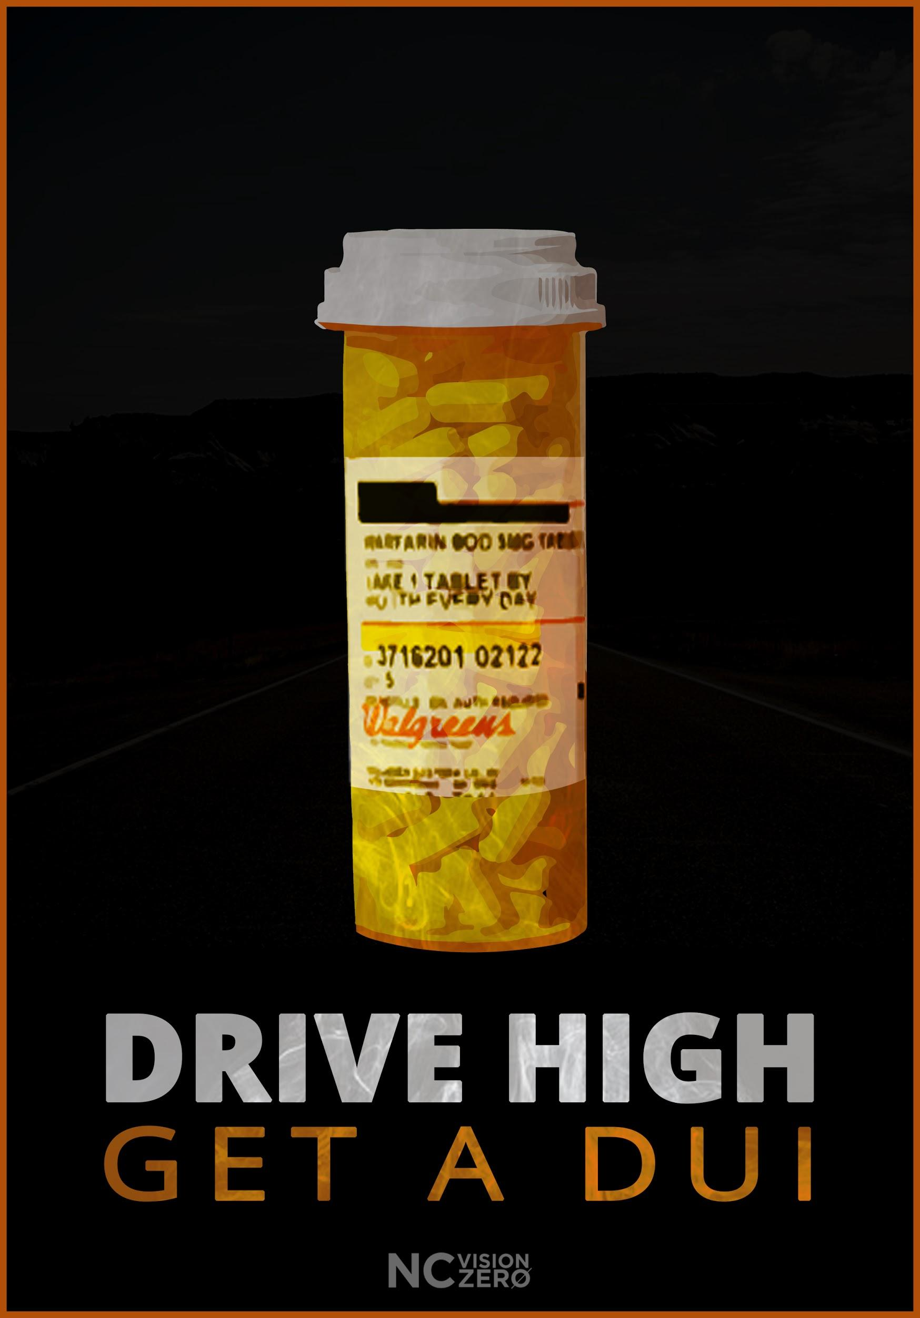
#Weed slows reaction time and increases your likelihood of a crash. @ncvisionzero https://goo.gl/e413ia | 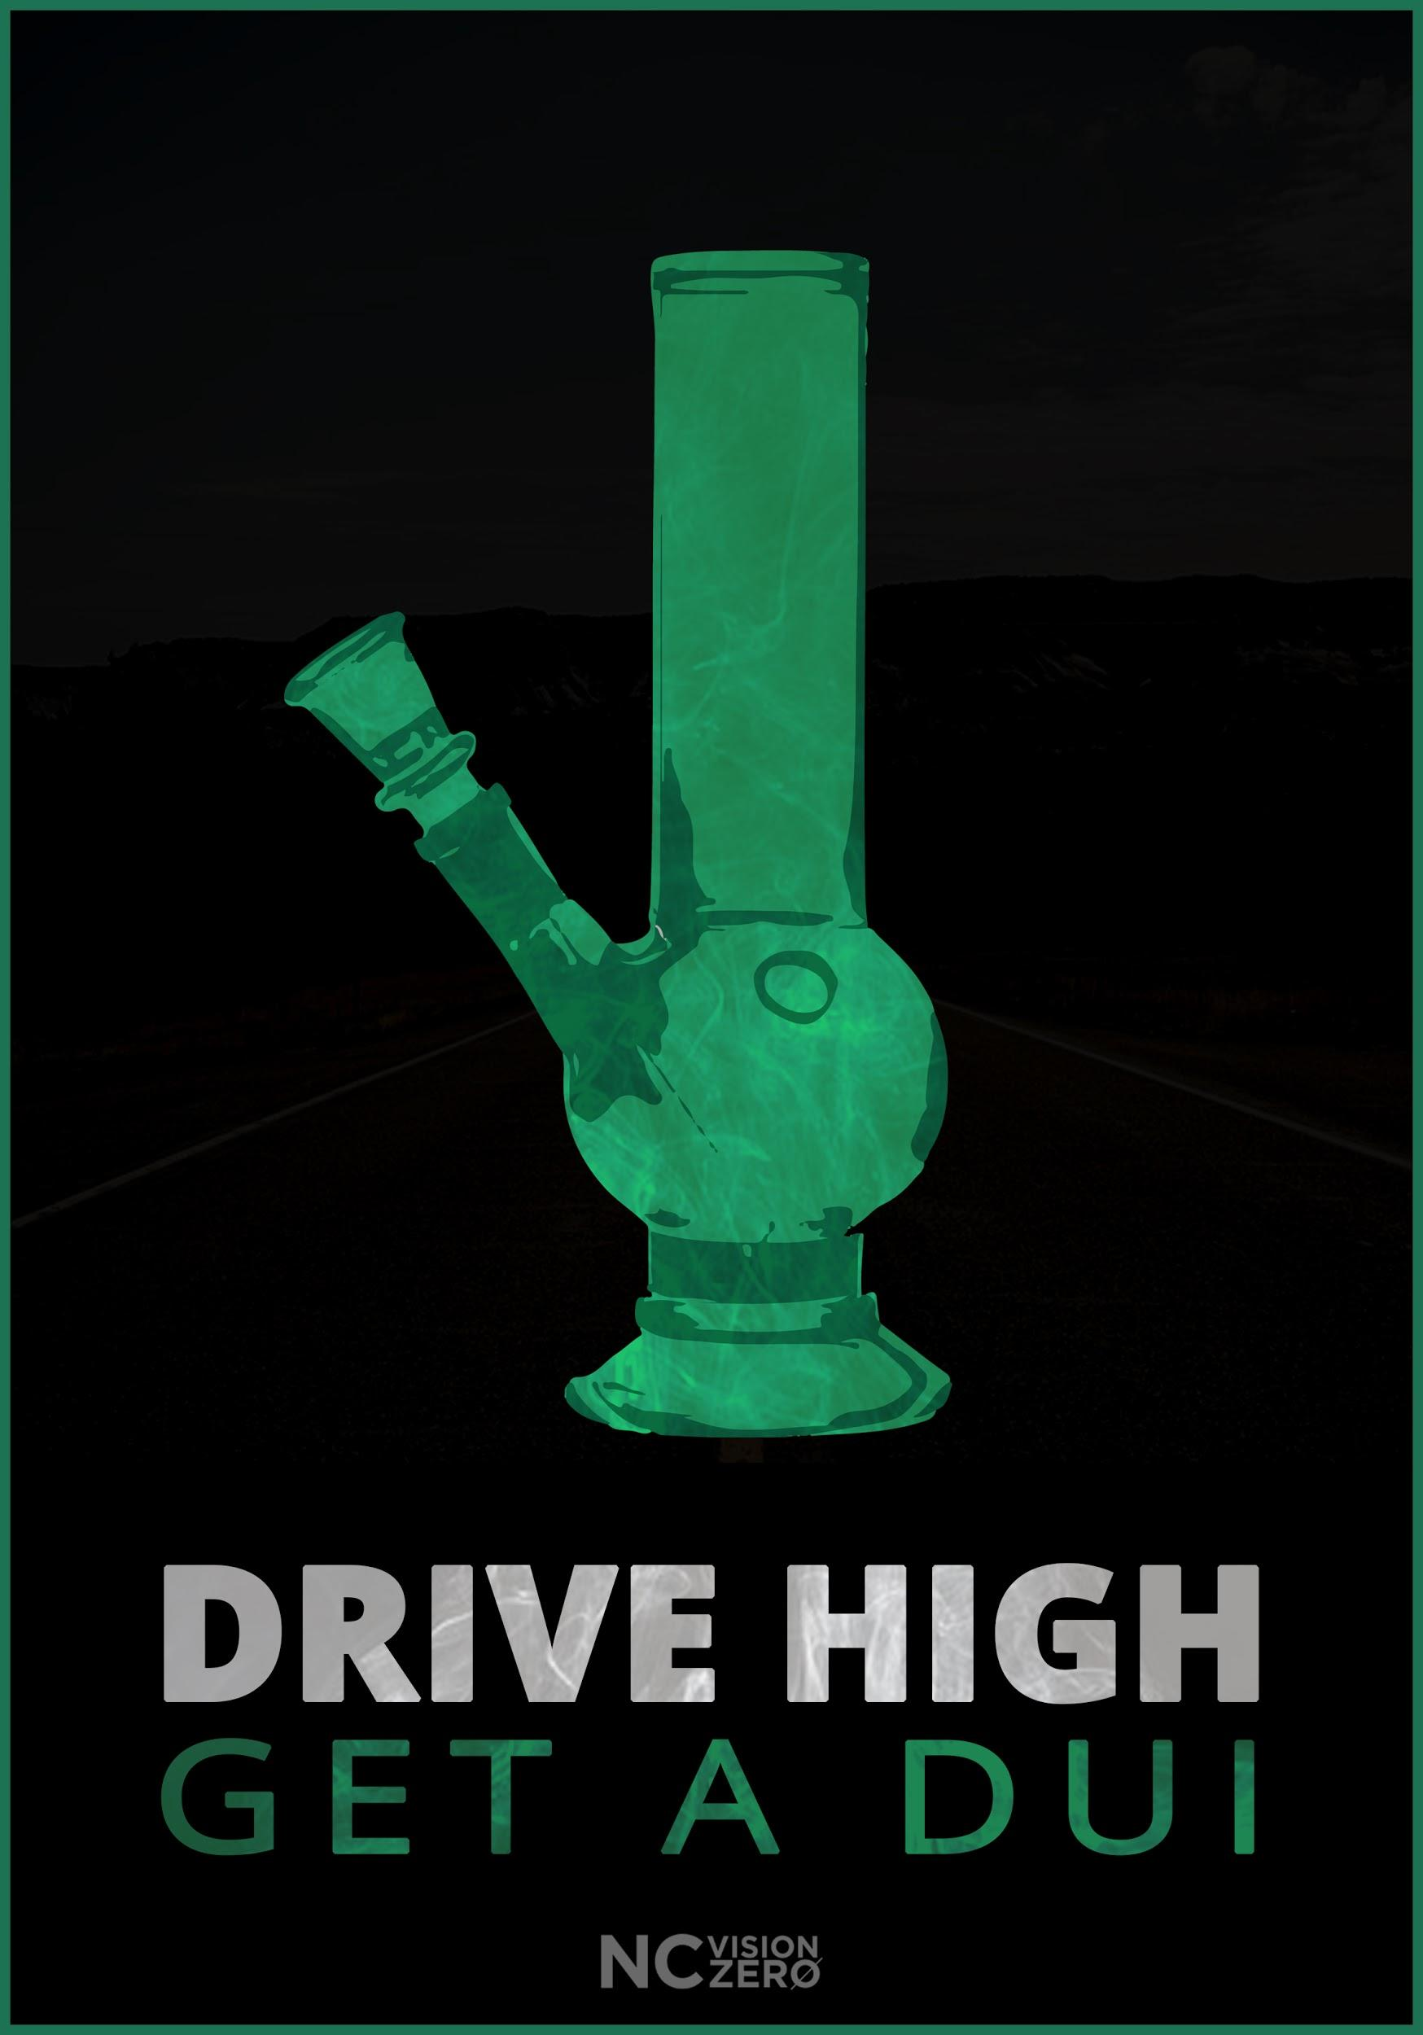

Pedestrian Safety

Post | Preview of Visual
Always look for people. Especially while turning. #watchformenc @bikewalknc @ncvisionzero https://goo.gl/Hqg6Pm | 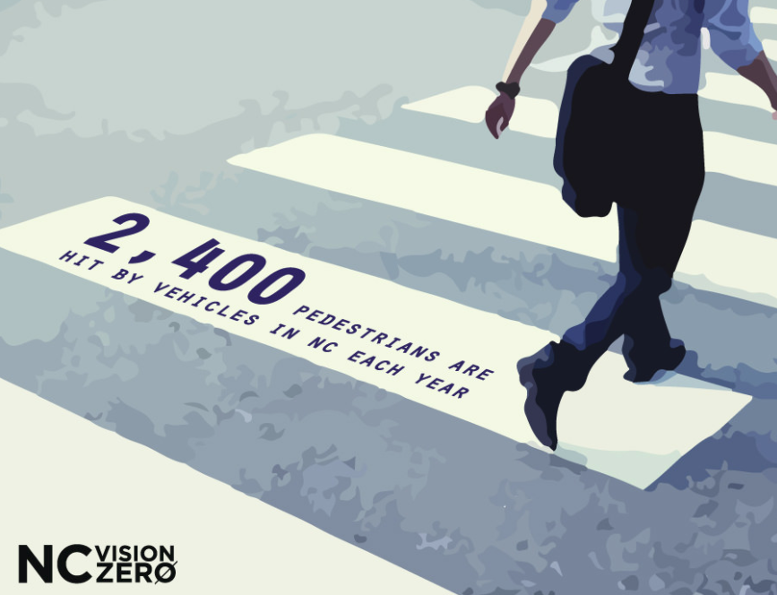
17% of people killed on North Carolina roads in 2016 were not in motor vehicles. #pedestrians #bicycles #watchformenc @bikewalknc @ncvisionzero https://goo.gl/images/5HdUyD | 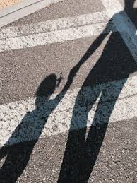
#MRW I see a pedestrian trying to cross the road and I stop and signal that he is safe to go. #watchformenc @bikewalknc http://gph.is/2IpYUsP | (gif)  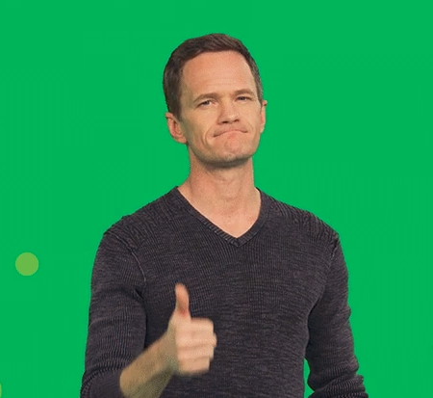
Yield to people - every road user is a loved one. #travelkindly #sharetheroad #watchformeNC @bikewalknc @ncvisionzero https://goo.gl/yK4pwr | (video)  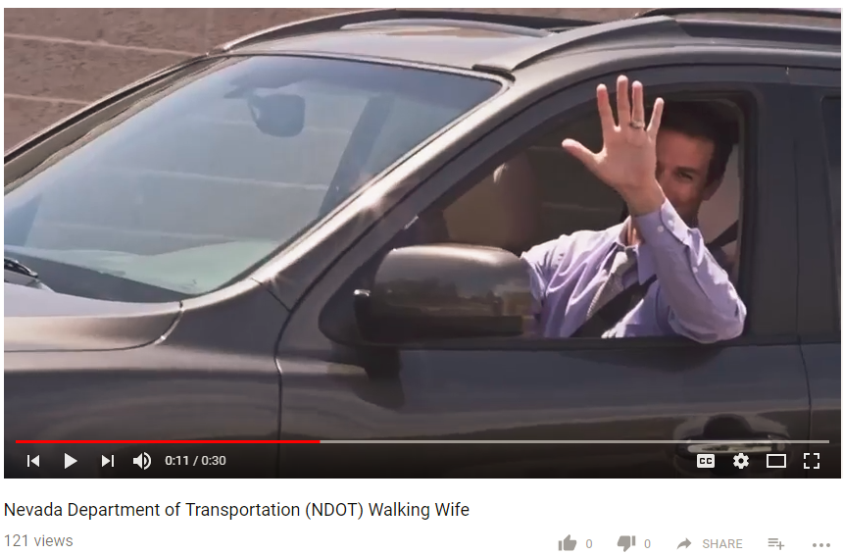
Heads up - we’re all responsible. #lookforpedestrians #travelkindly #watchformenc @zerofatalities @bikewalknc @ncvisionzero https://goo.gl/Cajwsp | (video)  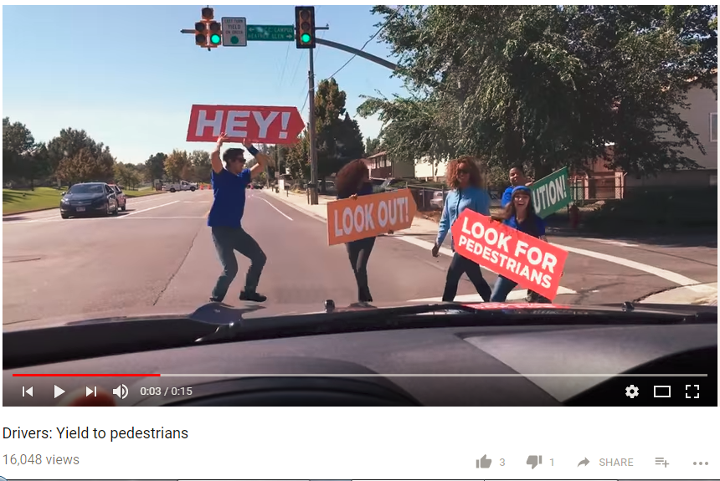
Whether it’s a short walk in a parking lot or a long trek to work—we’re all pedestrians. When people share spaces with 2-ton steel machines, it’s important that we all watch out for each other. #watchformeNC @ncvisionzero @bikewalknc | 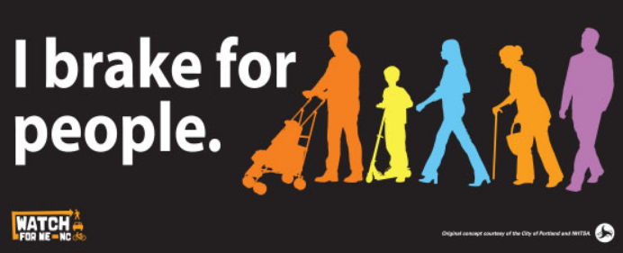
A small difference in speed can be the difference between life and death. #whatstherush #speedkills #watchformenc @ncvisionzero https://bit.ly/2IglQtK | 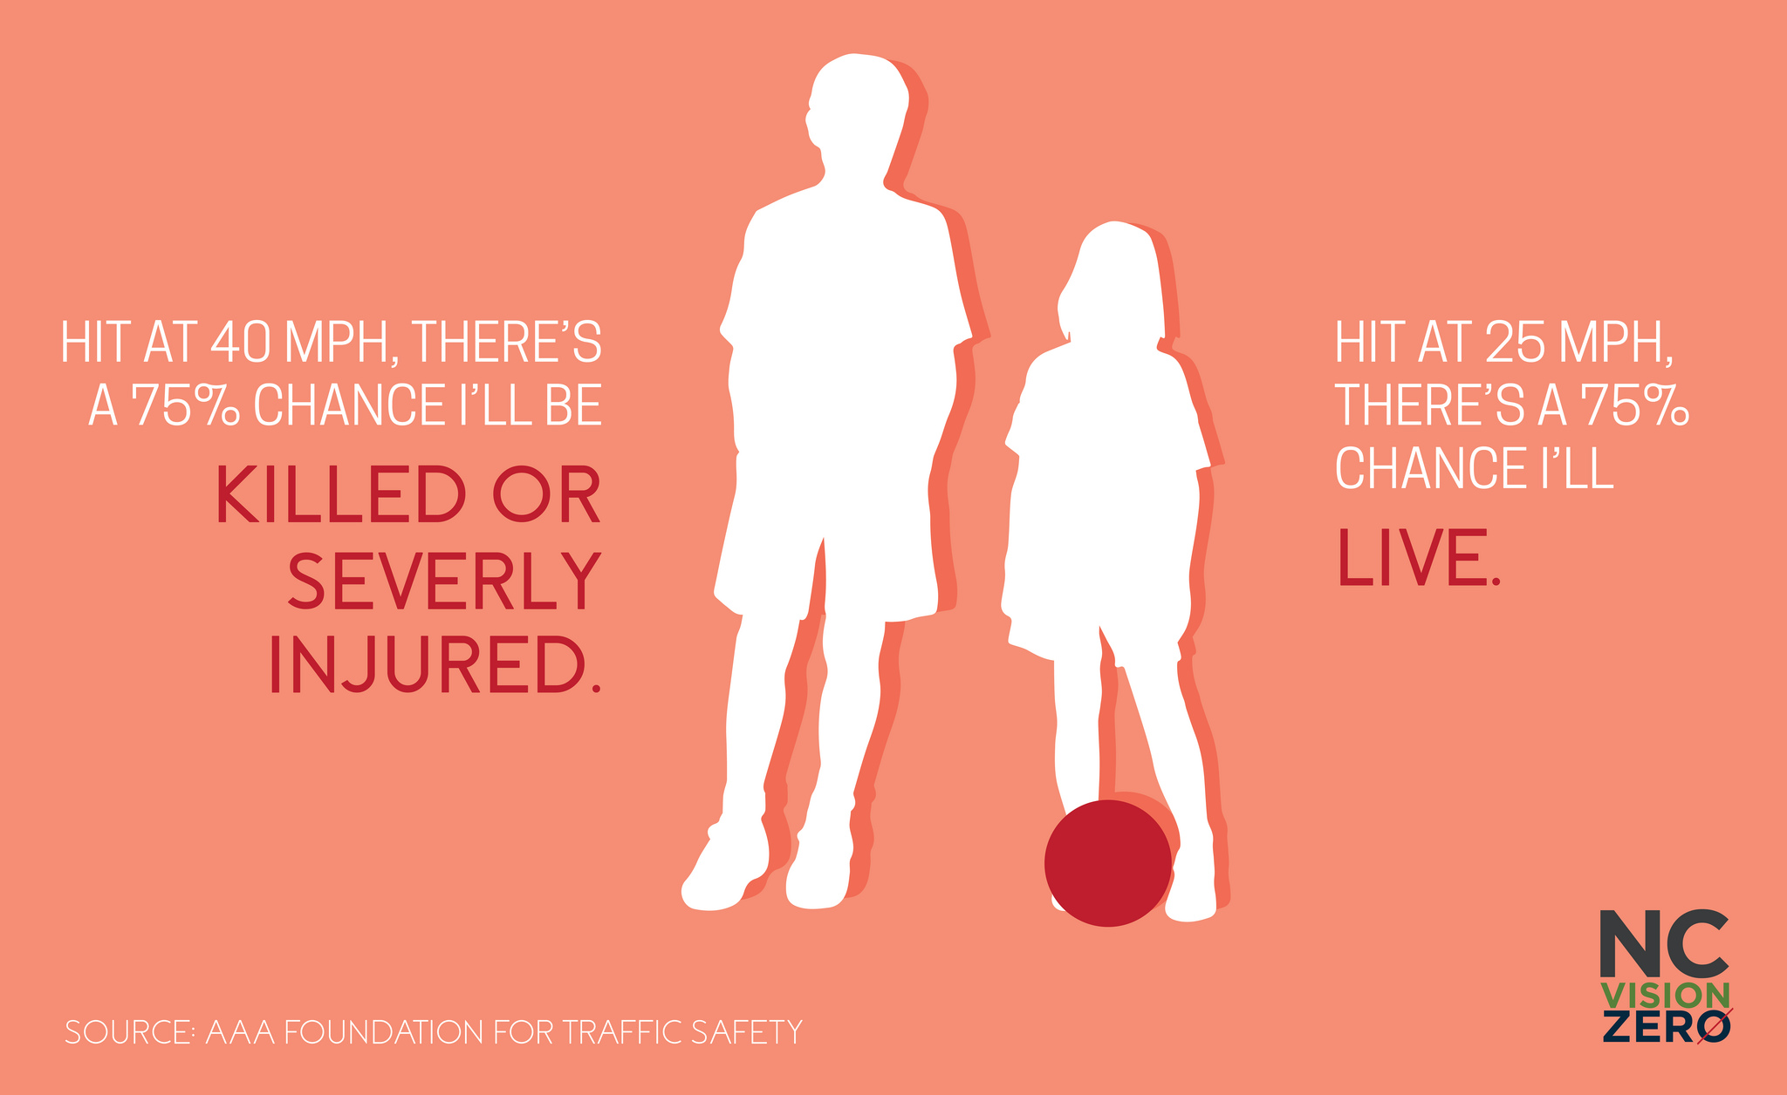
Watch for people and save a life. #watchformenc @ncvisionzero @circulateSD https://bit.ly/2GD9aQt | (video)  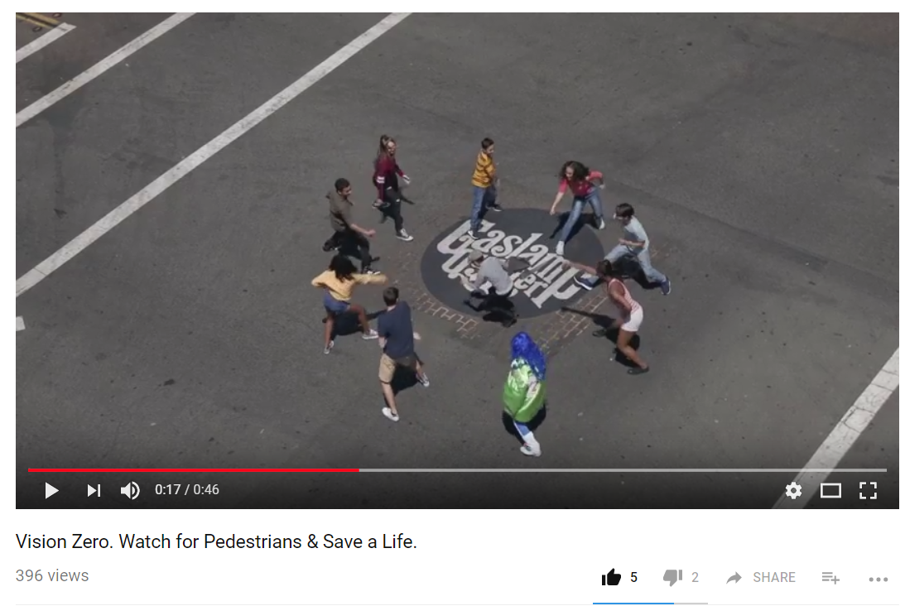
Pay attention. Your choices matter. #JustDriveNC #watchformenc #visionzero @ncvisionzero @nycdot https://bit.ly/2GChgc7 | (video)  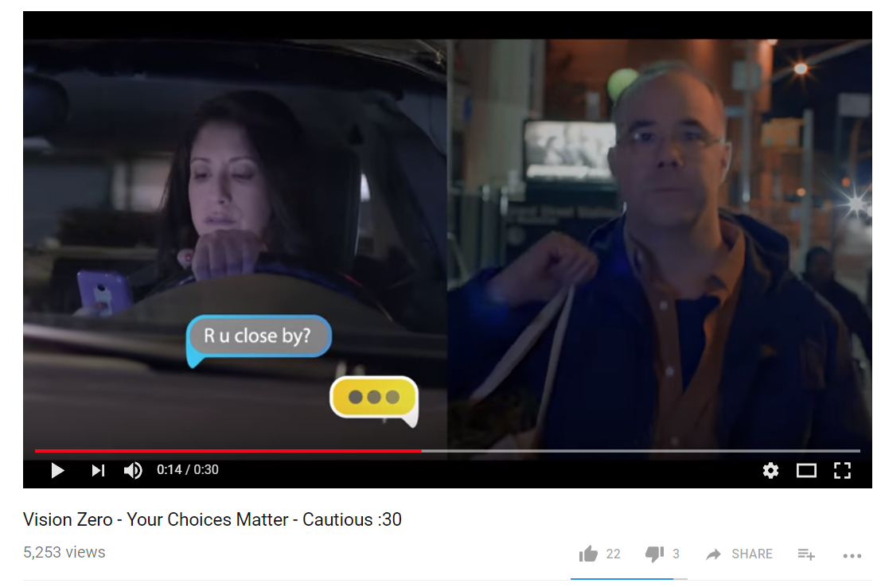

Teen Driver

Post | Preview of Visual
Car crashes are the #1 cause of death for teens in North Carolina. Before you hand over the keys, discuss and enforce the #5todrive. https://goo.gl/TcZ7wJ | (video)  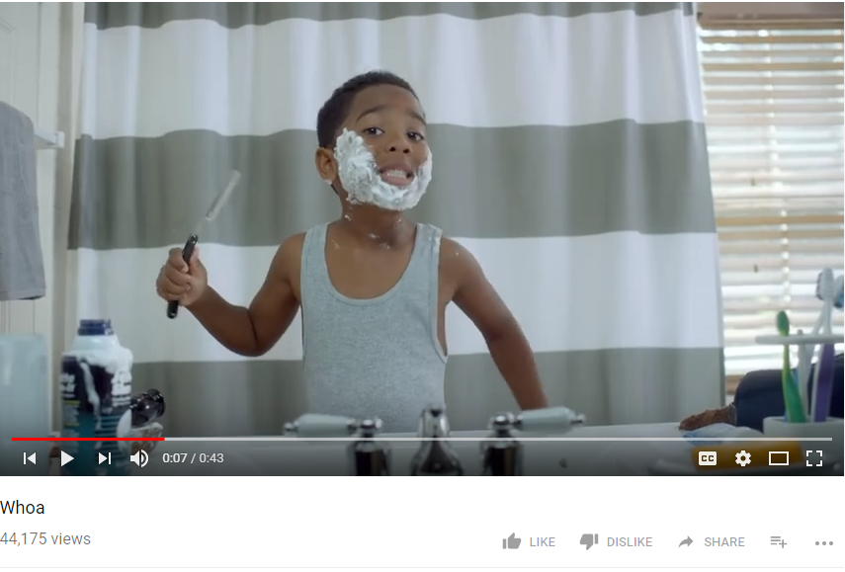
The first five years of driving are the most dangerous. Teen crash rates are highest within the first months of driving. The best thing you can do is ride and practice with them. Give them advice based on personal experience - and stay calm! #GDL @ncvisionzero https://bit.ly/2GLhmLm | 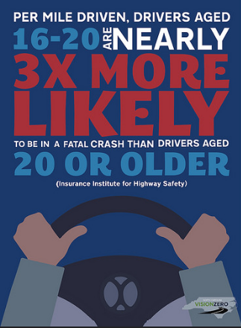
In North Carolina, all teen drivers must complete 60 hours of supervised driving. This experience will prepare your new driver to understand potential risks and safely navigate the roads when driving alone. #GDL @ncvisionzero https://bit.ly/2v0sEKl | 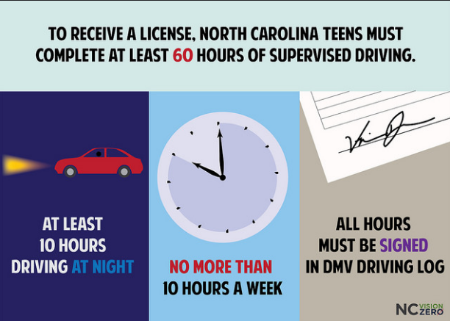

Seat belt safety

Post | Preview of Visual
Powerful reminder of the real reasons that we #buckleup. @ncvisionzero https://goo.gl/QQFygP | (video)  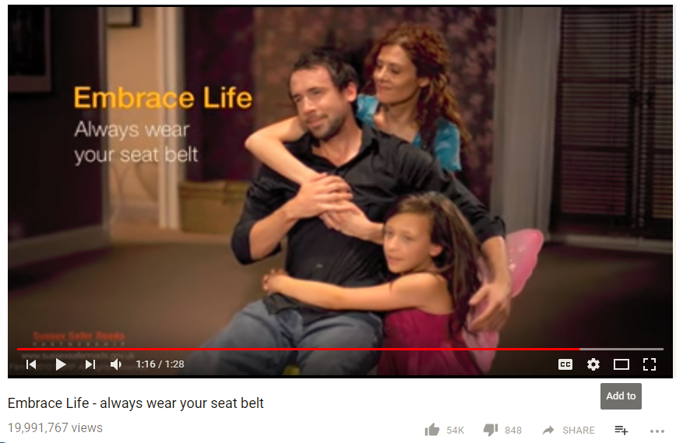
Anyone remember these guys? #TBT #VinceandLarry #buckleupNC @ncvisionzero https://gph.is/2njfUJc | (gif)  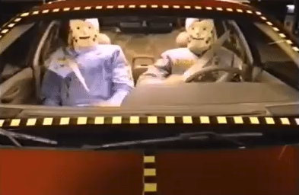
MOST North Carolinians buckle up. https://goo.gl/3qE7uc | 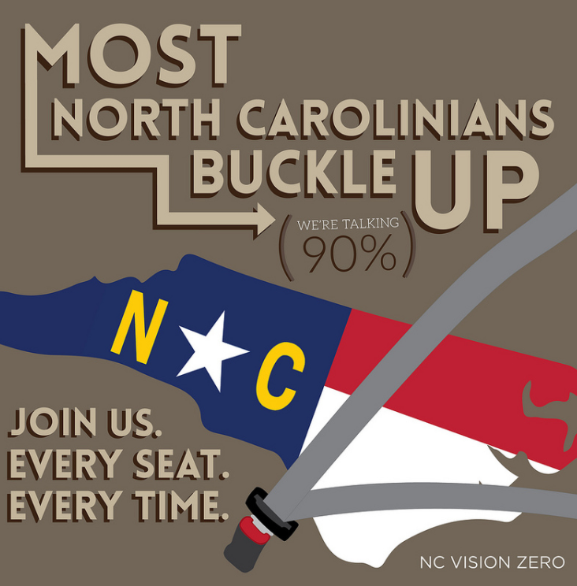
You’re a good driver, right? Buckle up to protect yourself from other drivers’ mistakes. #seatbelts #buckleupNC @ncvisionzero https://goo.gl/DUwTU1 | 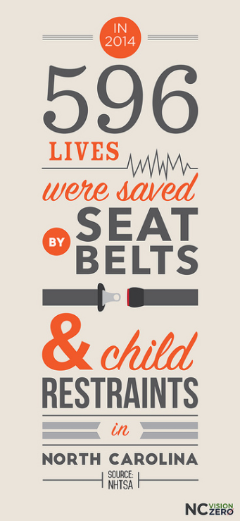
92% of North Carolinians buckle up. The rest of them? #meme #spongebob https://goo.gl/7B7vjA | 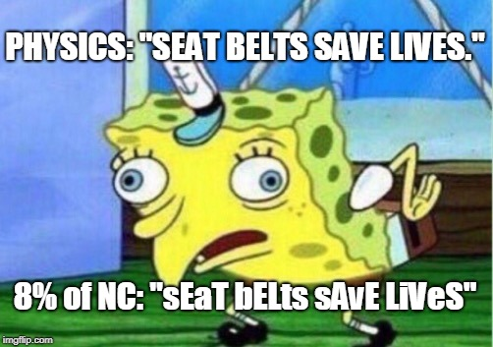
This is why you insist that everyone is buckled up. Every seat. Every time. #buckleupNC @ncvisionzero https://goo.gl/kkD3q7 | 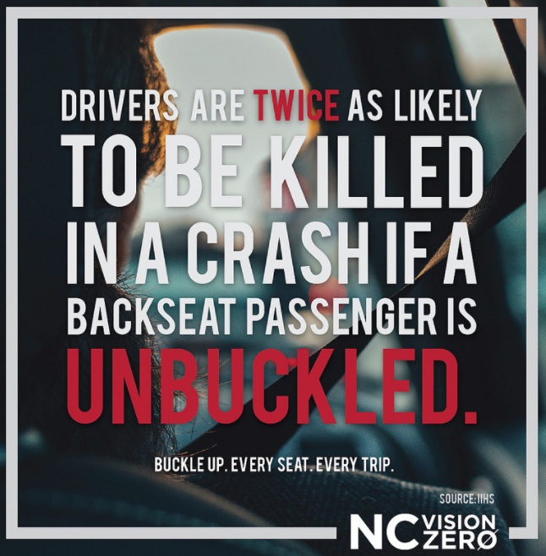
42% of the people killed on #NorthCarolina roads last year were unbuckled at the time of the crash. Protect yourself and your loved ones - buckle up. Every seat, every time. #noexceptions #buckleupnc @ncvisionzero https://goo.gl/aZeEF5 | 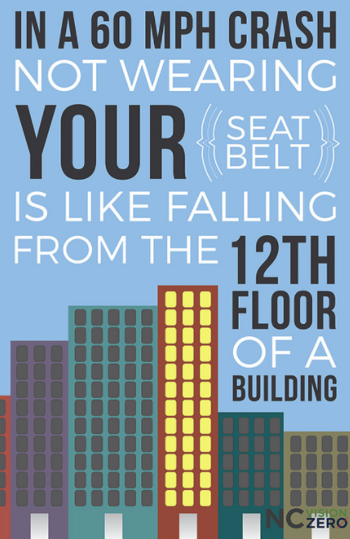
#MRW someone gives me an attitude when I ask them to #buckleup. @ncvisionzero https://goo.gl/images/URFY9p | 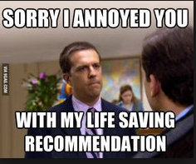
MOST North Carolinians #buckleup. The rest? #spongebob #meme @ncvisionzero https://goo.gl/SZtGd3 | 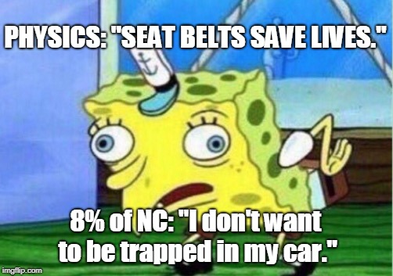
This is #whywebuckleup in every seat, every time. #seatbelts #parents @ncvisionzero @carolinaparent https://goo.gl/KaE69S | (video)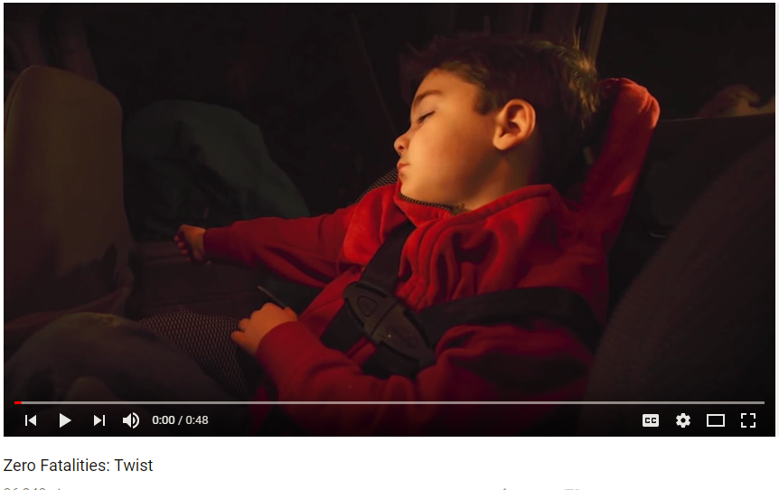
Your best chance of surviving a crash is being buckled. #buckleupNC @NCVisionZero https://goo.gl/2JR2k4 | 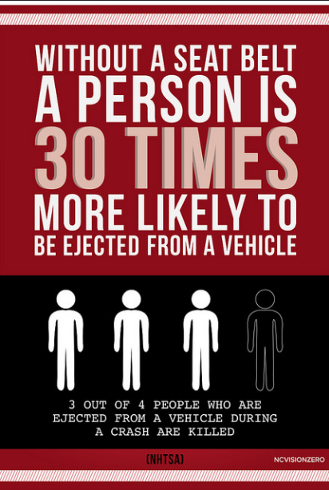
You mean a lot of different things to a lot of different people. #Buckleup for the people who depend on you. @ncvisionzero @roadsafetycommission https://goo.gl/2qPWLR | (video)  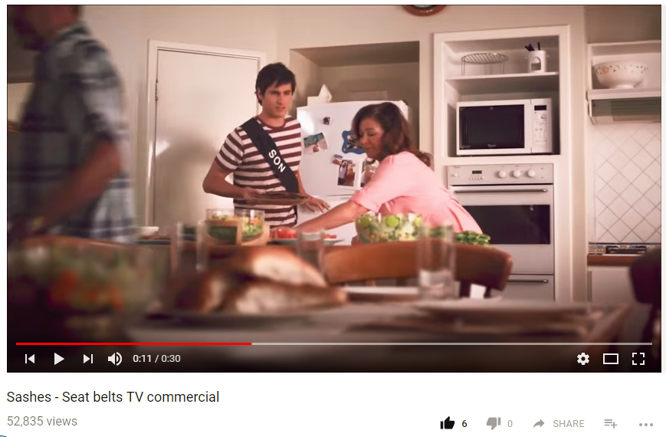
Riding with an unbuckled passenger increases your risk of being hurt or killed by 40%. #buckleupnc @ncvisionzero @coloradodot https://goo.gl/pTFXKG | 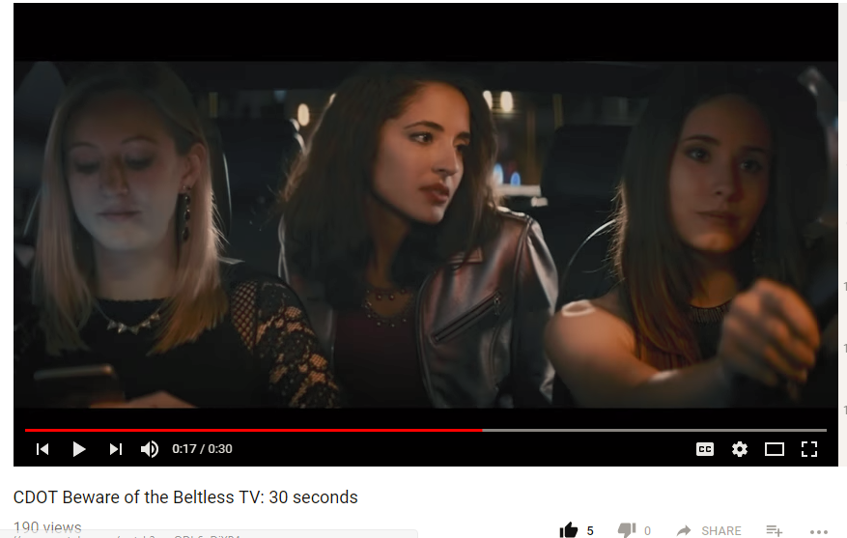

Speeding

Post | Preview of Visual
Racing through a yellow light will only get you to the next red one faster. #slowdown #speedkills #whatstherush @ncvisionzero https://bit.ly/2qpG8ur | 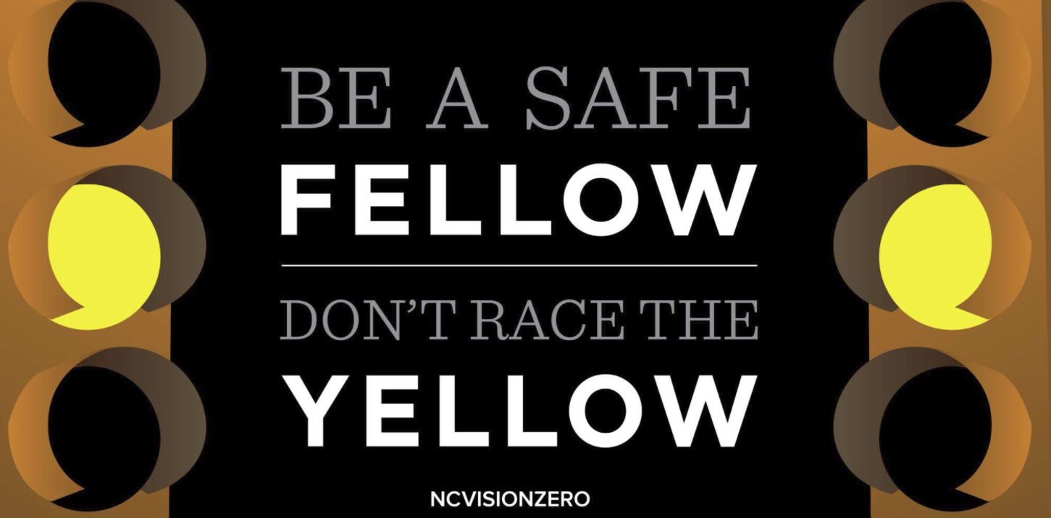
Speed isn’t about arrival time, it’s about survival. When other drivers are unpredictable, your speed is under your control. #speedkills @ncvisionzero https://goo.gl/pUvyGe | 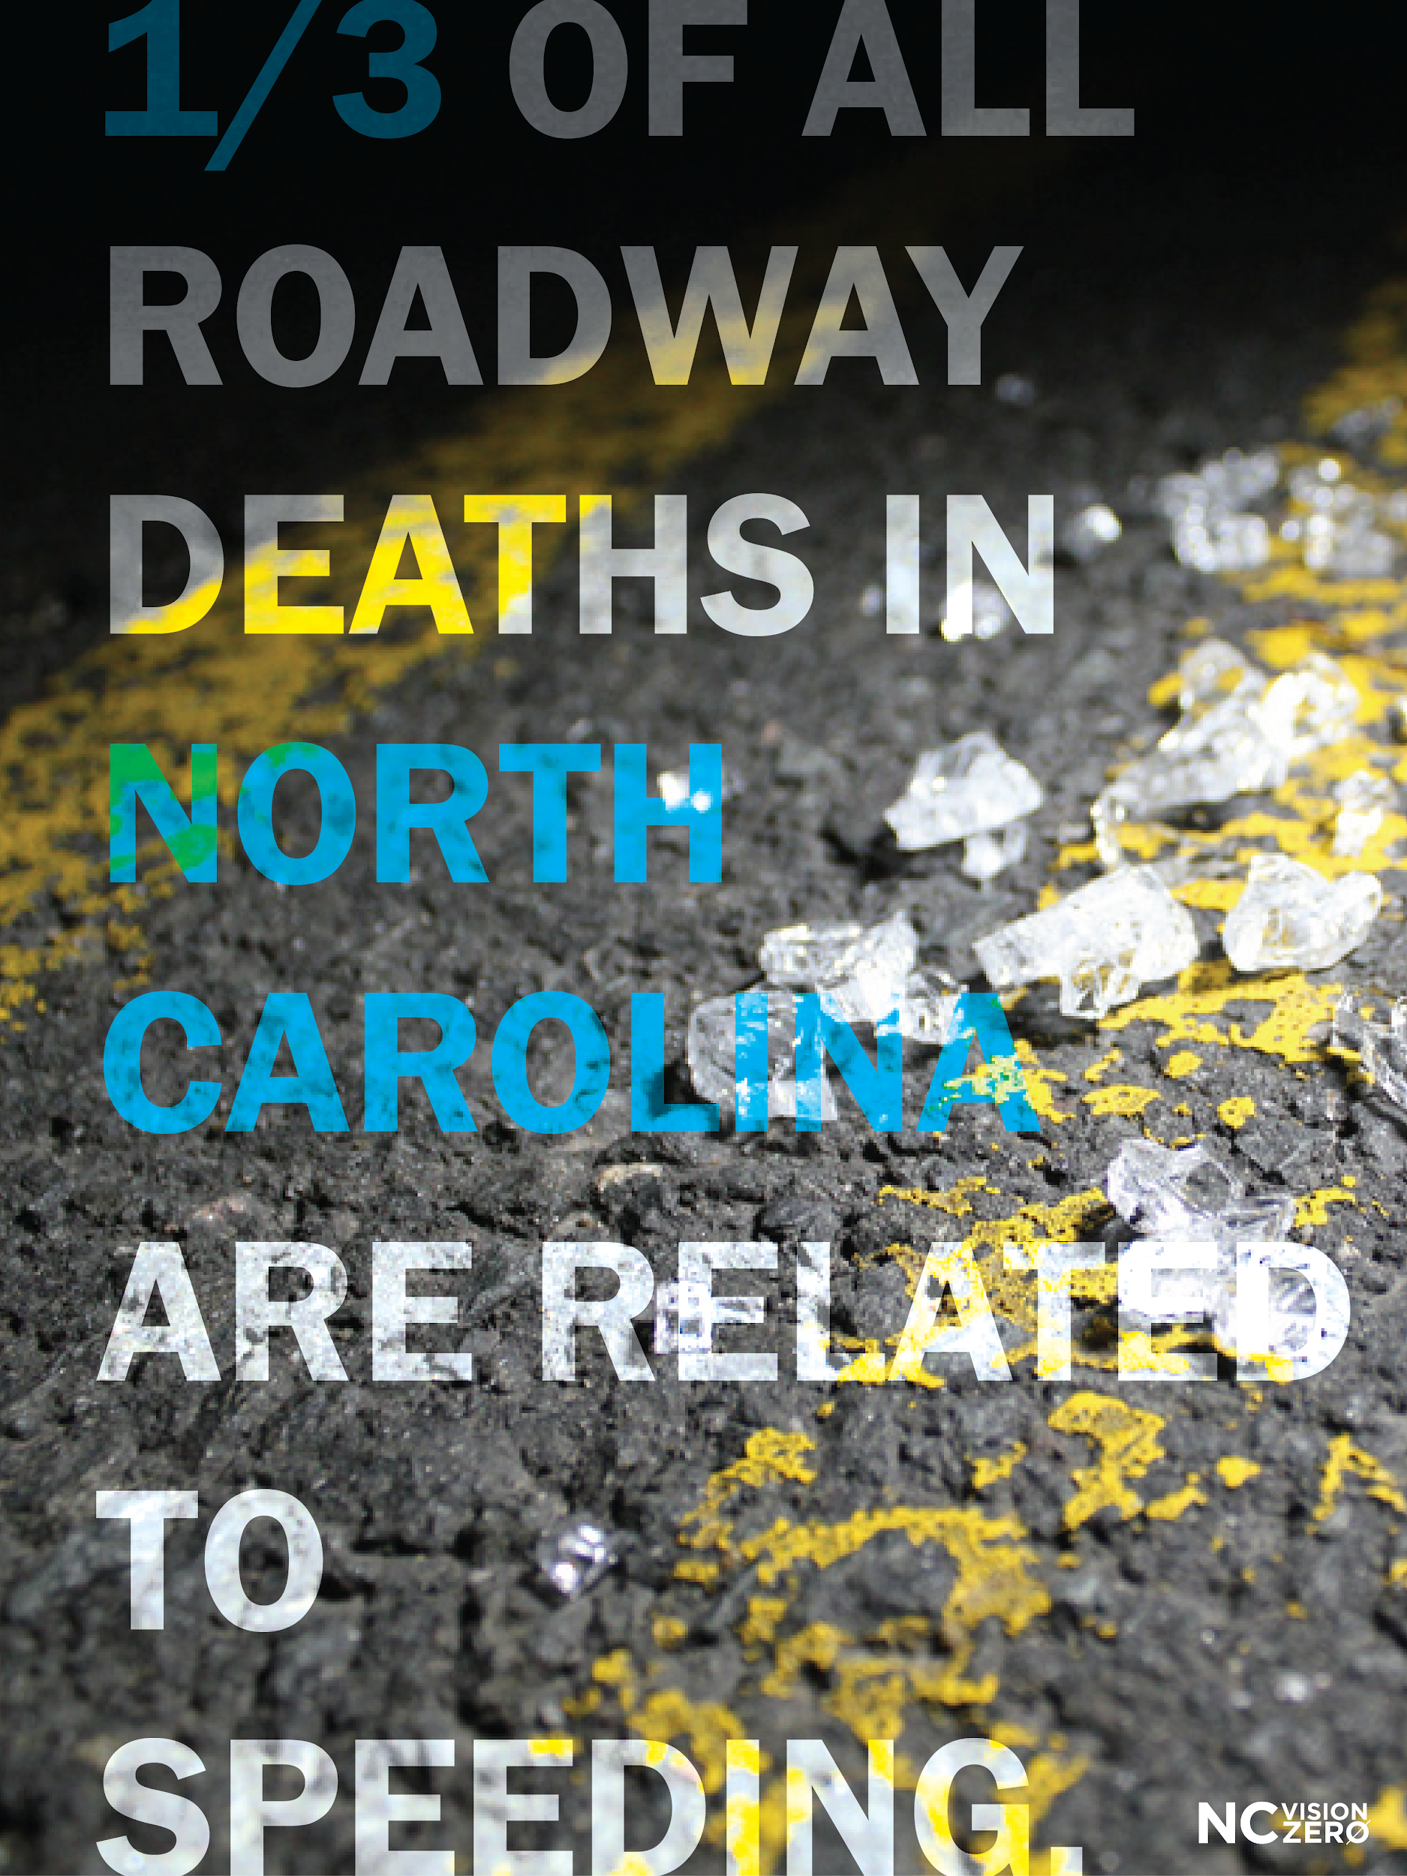
Tag someone who can relate. #whatstherush #slowdown @ncvisionzero https://goo.gl/images/92TjVF | 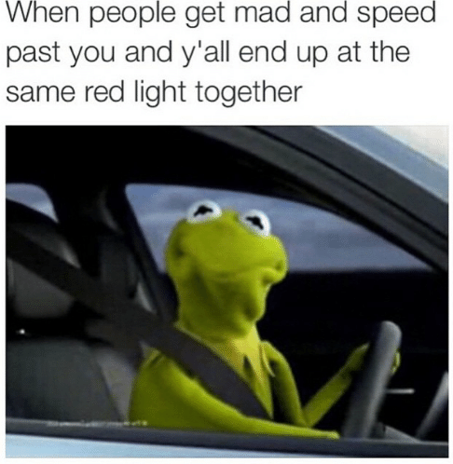
No one is impressed by selfish, dangerous driving. #whatstherush #speedkills #notimpressed @ncvisionzero https://goo.gl/mWL99n | 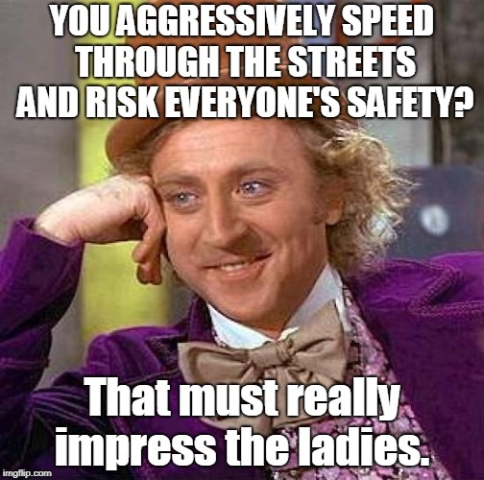
Can anyone relate? #whatstherush #meme #speedkills @ncvisionzero https://goo.gl/g72fTW | 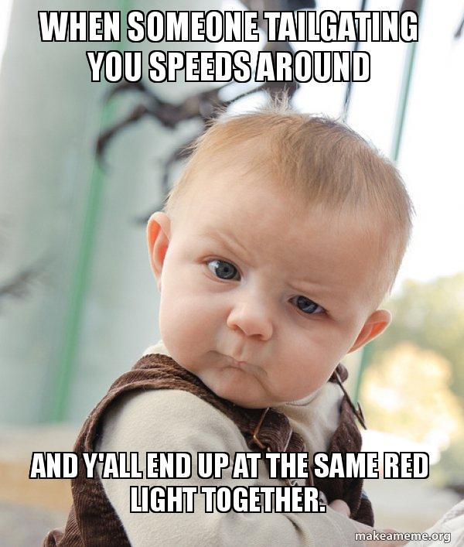

School Bus

Post | Preview of Visual
Protect your community’s children. Never pass a school bus with the stop arm displayed. @ncpublicschools @ncvisionzero https://goo.gl/E4ThGb | 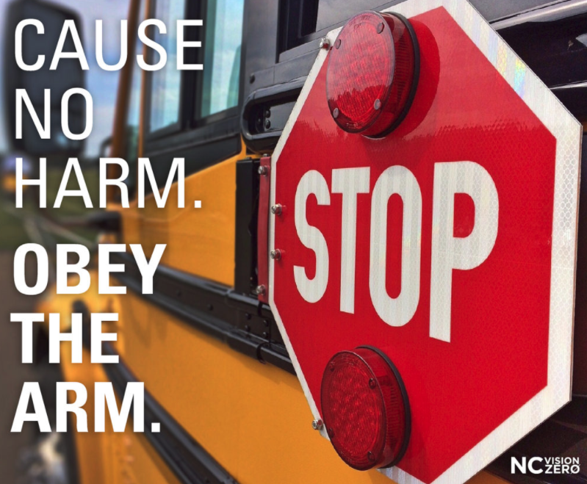
If your child can safely walk or bike to school - fantastic! If not, the #schoolbus is your best option. @ncpublicschools @safekidsnc @ncvisionzero https://goo.gl/CCf2e8 | 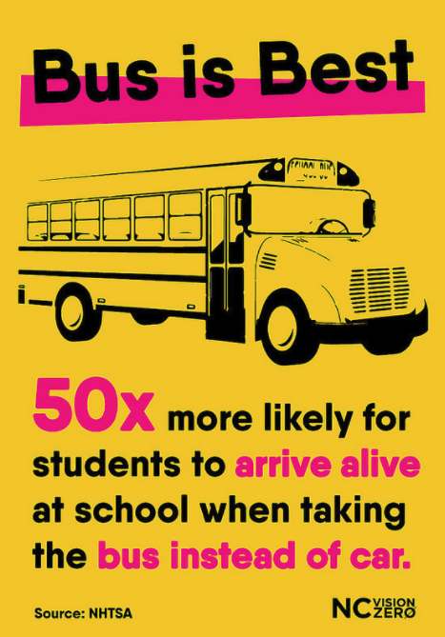

Large Truck/CMV Safety

Post | Preview of Visual
Big trucks have lots of blind spots. Look for the mirrors! @ncvisionzero https://goo.gl/dp4jC4 | 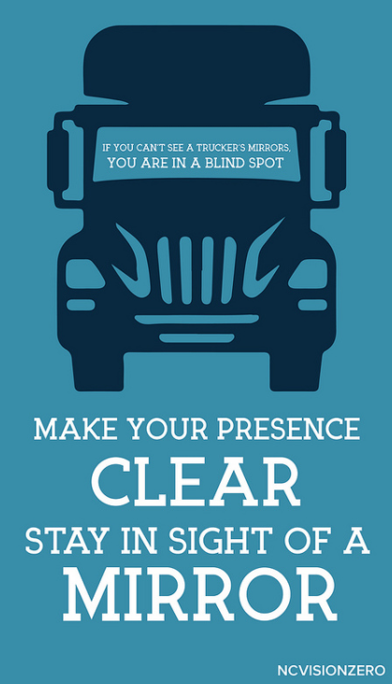
Drivers get a chance to sit a large truck. You’ll be shocked to see what they find out. #BeTruckAware @NorthCarolinaTruckingAssociation @trucksafetycoalition @NCVisionZero https://goo.gl/eTxnJQ | (video)  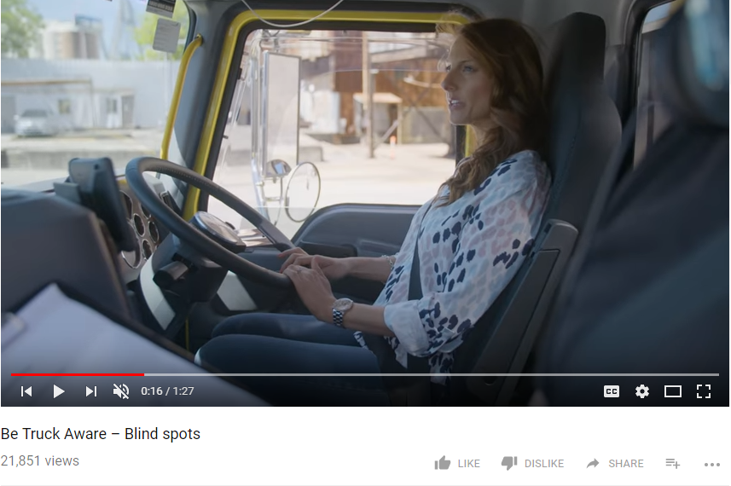

Motorcycle Safety
Any experienced biker will tell you - wearing the right gear is the smart choice. #bikerlife @ncvisionzero https://goo.gl/CwVY5v | 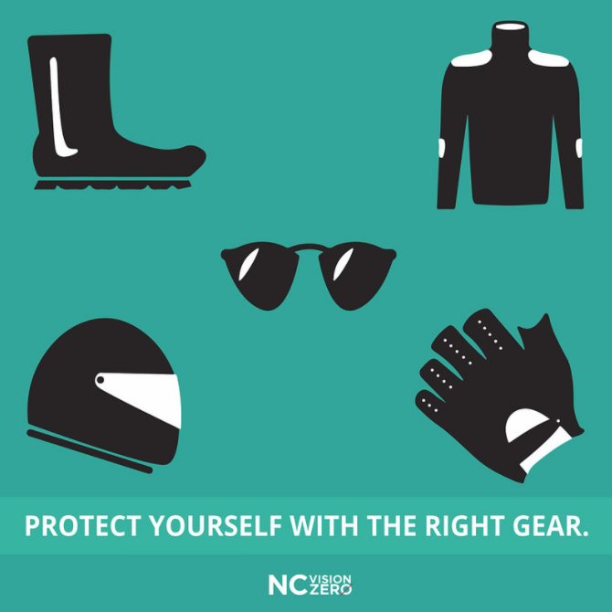
Take care when turning left. 41% of fatal motorcycle crashes with another vehicle involved a vehicle turning left in front of a motorcycle. #bikesafenc @nhtsa @ncvisionzero https://bit.ly/1XcgMKv | 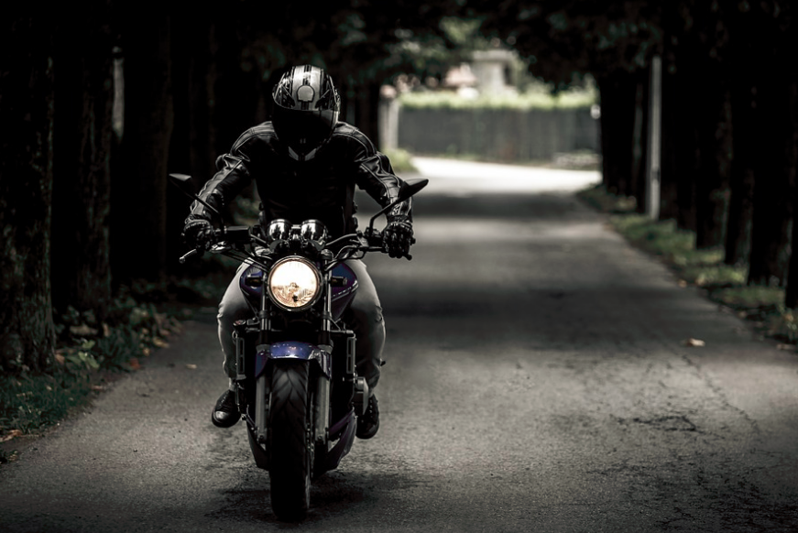

Work Zone Safety

Post | Preview of Visual
#workzone @ncltap @ncvisionzero https://goo.gl/aT8Ki3 | 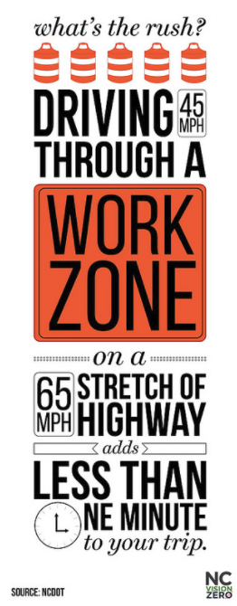

Holidays

New Years

Post | Preview of Visual
The #newyear is full of promise. Let's start it out right. If you're drinking a toast to #2019 tonight - grab a #Lyft or #Uber. And get one for your friends too. Happy New Year everyone. @ncvisionzero https://goo.gl/gLQwVP

Valentine’s Day

Post | Preview of Visual
This #ValentinesDay, tell the ones you love to buckle up. #buckleupNC #bromance @ncvisionzero https://goo.gl/kq6wgH | (video)  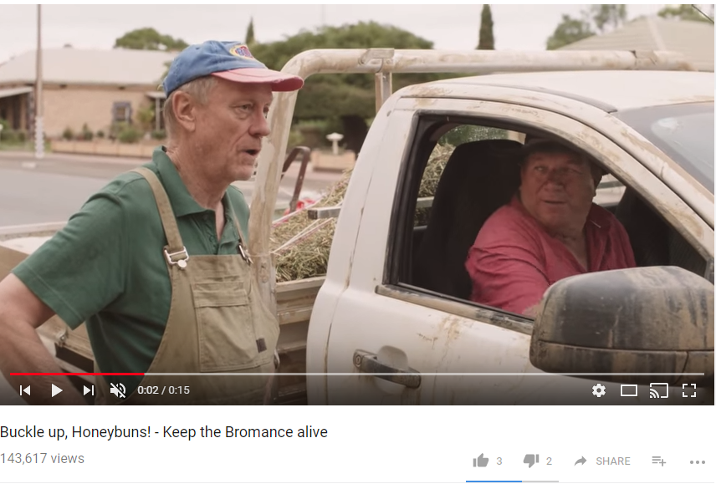

July 4th

Post | Preview of Visual
The most patriotic thing you can do today: don’t drive after drinking. #4thofJuly #America @NCVisionZero https://goo.gl/4EE4V1 | 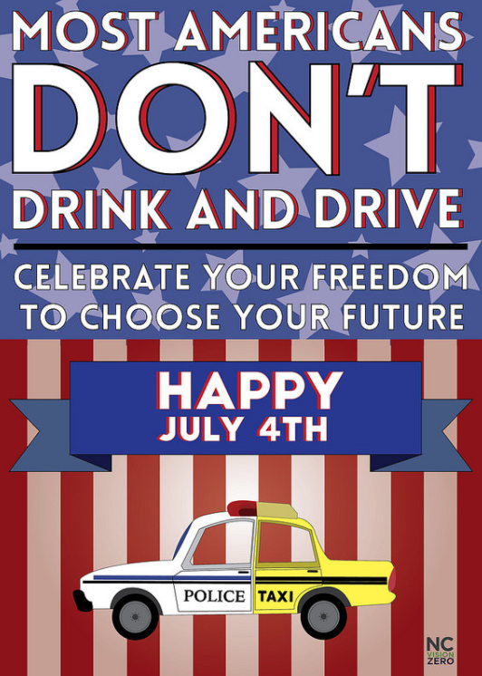

Halloween

Post | Preview of Visual
No matter what your costume is - today, you can be a hero. #Halloween #boozeitandloseit #drivesober @ncvisionzero https://goo.gl/6PrRMV | 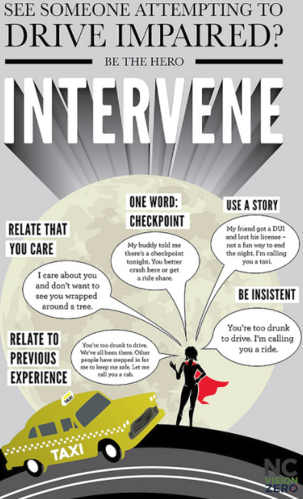
Lots of cute little characters on the roads tonight. Drive alert and sober - and Happy #Halloween! @ncvisionzero https://goo.gl/images/bgE8Si | 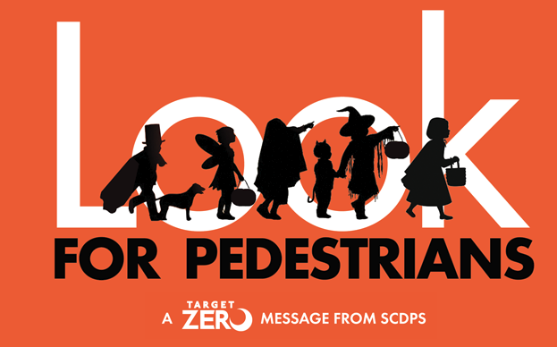

Christmas

Post | Preview of Visual
This holiday season - celebrate! Enjoy your family and friends. Gather and be merry! But if your celebrations involve alcohol - plan a safe, sober ride home. #homefortheholidays #Christmas @ncvisionzero https://goo.gl/images/fqB9uj | 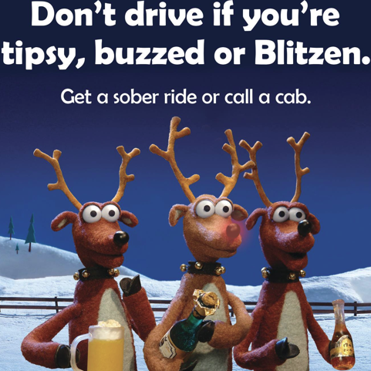

Law Enforcement

Post | Preview of Visual
They’re out there to help people. Let’s give them space. @nchighwaypatrol @ncpublicsafety @ncemergency @ncvisionzero https://goo.gl/kz1yjJ | 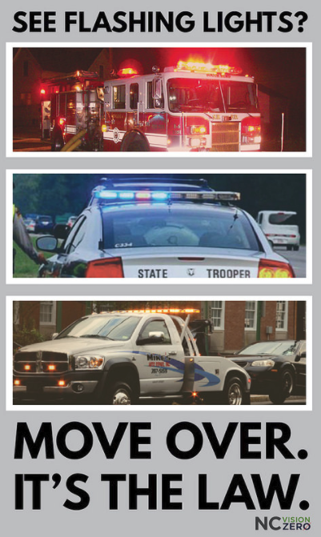

Additional Content

Videos
- The NC Vision Zero YouTube Channel has Traffic Safety Playlists by safety focus area. Best videos are compiled into shorter playlists:
  - Traffic Safety Compilation list
  - Best of Seat Belt Safety
  - Top Distracted Driving
  - Top Drinking and Driving
  - Best of speeding safety
  - Top Motorcycle
  - Top Child Passenger Safety
  - Top Young Driver Safety
  - Top Work Zone Safety
  - Top Bicycle Safety
  - Top Rail Safety
  - Top Drugged Driving
  - Top Commercial Truck Safety

Images
- NC Vision Zero graphics and images by safety category are available at: go.ncsu.edu/ncvzimages

Gifs
- https://giphy.com/NCVisionZero

